The University of Maryland at College Park
Signal Reconstruction from Multiscale Edges
Author: Yen-Ming Lai () AMSC
Advisor: Radu Balan (rvbalan@math.umd.edu), MATH, AMSC, CSCAMM
7th May, 2011

Abstract
We reconstruct a one-dimensional discrete signal using only the local extrema of the signal’s discrete dyadic wavelet transform and the method of alternate projections. The local extrema correspond to edges of the input signal.

Background
In their 1992 paper, “Characterization of Signals from Multiscale Edges”, Stephane Mallat and Sifen Zhong [1] reconstruct an one-dimensional signal using only the local extrema of the dyadic wavelet transform and the method of alternate projections. The wavelet transform provides a decomposition of signal, albeit redundant. The wavelet transform is a convolution of the original signal against the dilates of a chosen mother wavelet. Since mother wavelets have finite support and have zero mean, their shape resembles that of an edge.
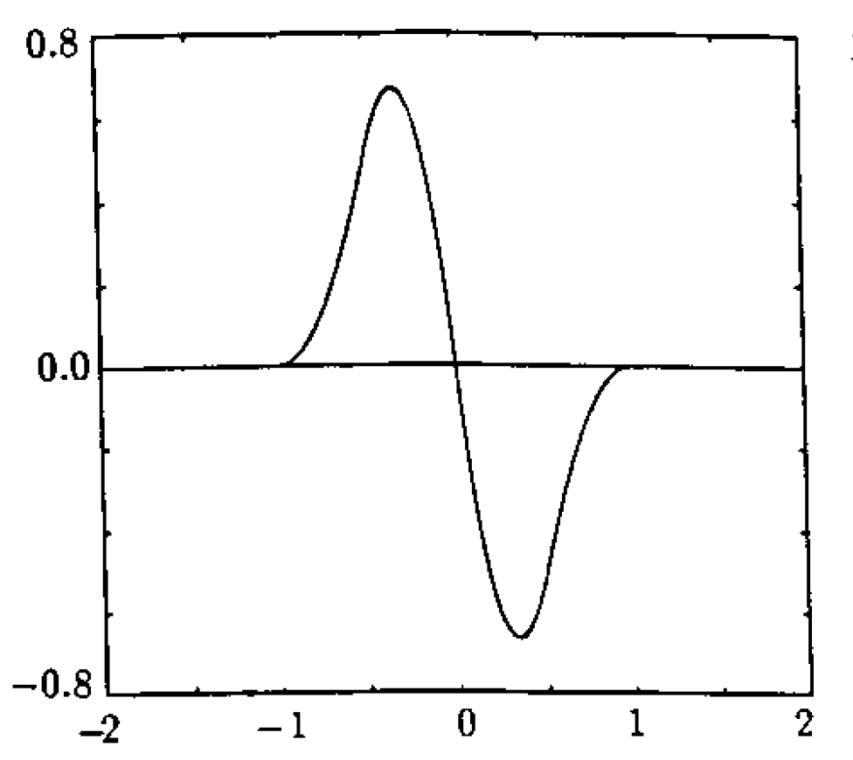
Figure 1 - Quadratic Spline mother wavelet [1] (Figures reused with author’s permission.)
Convolution can be thought of as a best match operator, and as a result the local extrema of the wavelet transform correspond to the original signal’s edges.
The method of alternate projections assumes that an ideal solution has two properties. First, the reconstructed signal is “smooth” in the sense that the signal has finite H1 norm. Second, the wavelet transform of the reconstructed signal has the same local extrema as the wavelet transform of the original signal.

Mallat’s and Zhong’s Results
Mallat’s and Zhong’s paper [1] showcased a signal that included different types of edges.
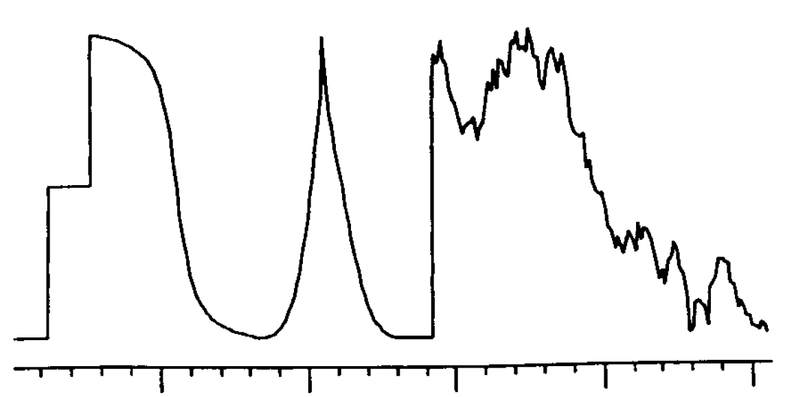
Figure 2 - Input signal with different types of edges (256 values) [1]
Step edges occur in the first third of the signal, a sharp double sided edge in the second third, and multiple noisy edges in the last third.
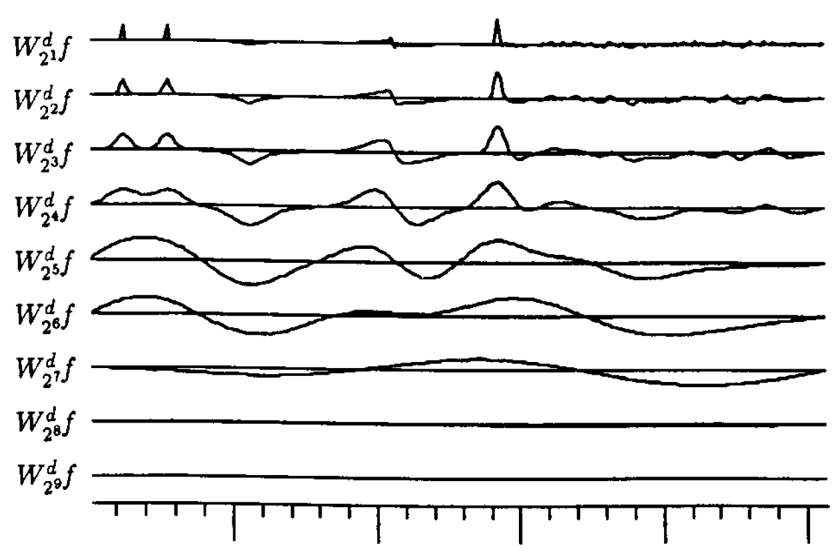
Figure 3 - Discrete wavelet transform using Quadratic Spline mother wavelet [1]
The local extrema of the wavelet transform correspond to the edges of the original signal. Only major edges are detected at higher transform levels since the convolving wavelet has been further dilated.
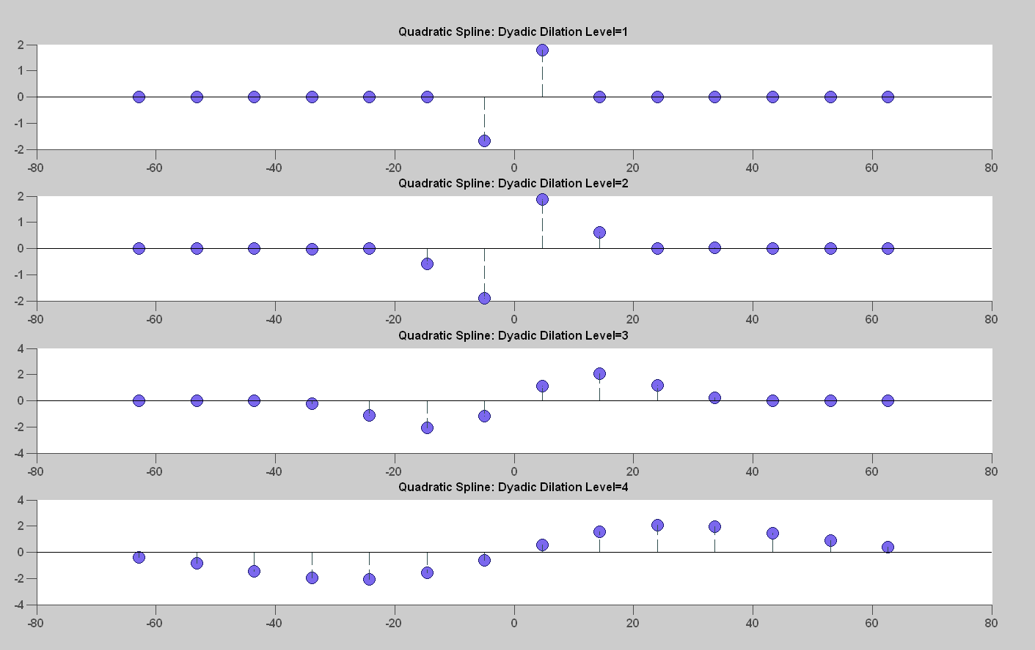
Figure 4 - Quadratic Spline wavelet dilated at four levels
Major edges are detected across all transform levels whereas minor edges are only detected at the lower transform levels. Furthermore, the type of edge produces influences the shapes of the local extrema. Hence, the evolution of local extrema across transform scales encodes the edge type of the original wavelet.
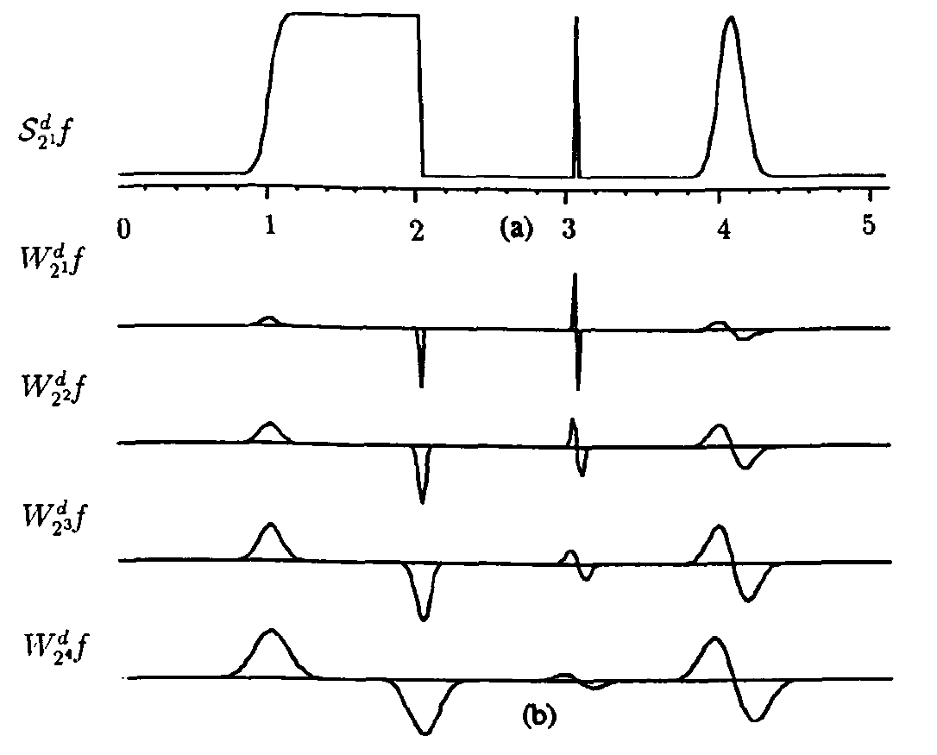
Figure 5 - (a) Input signal (b) Wavelet transform with Quadratic Spline wavelet [1]
Mallat and Zhong were able to show logarithmic convergence using the method of alternate projections.
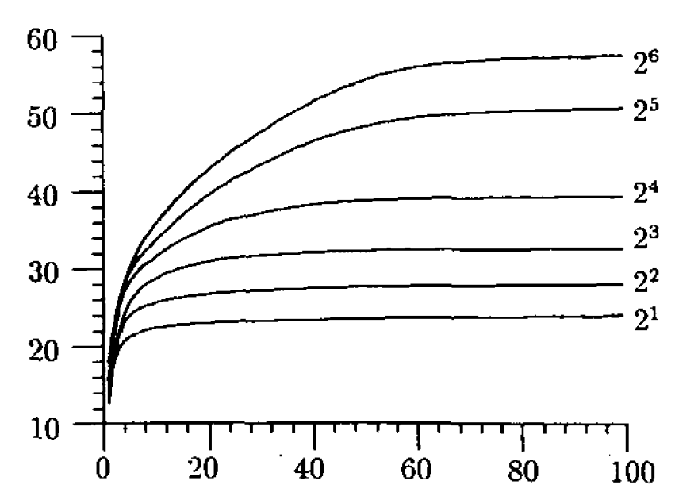
Figure 6 - SNR of reconstructed signal’s wavelet transform [1]
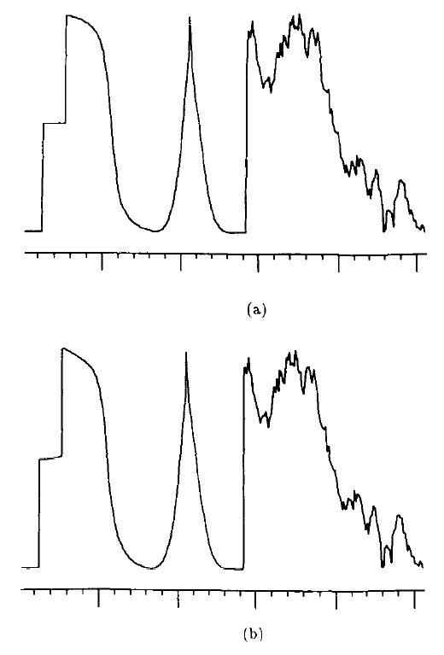
Figure 7 - (a) Original signal (b) Reconstructed signal after 20 iterations [1]

Approach
Mallat’s and Zhong’s algorithm consists of four parts. First, the redundant (non-decimated) dyadic wavelet transform is taken. Second, only the local extrema of the wavelet transform are saved. Third, the method of alternate projections is applied to find approximation of original signal’s wavelet transform. Finally, the inverse dyadic wavelet transform of the approximation is taken to reconstruct the signal.
Their approach is summarized below.

Dyadic Wavelet Transform
To compute a dyadic wavelet transform, a mother wavelet is first chosen and then dilated by powers of two. The mother wavelet along with its dyadic dilates are convolved against the original function to produce a sequence of functions termed the dyadic wavelet transform.
Specifically, let 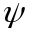 denote the mother wavelet which is a function with zero mean. The dyadic dilation at level is given by
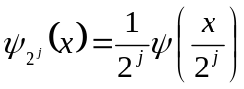.
The wavelet transform of 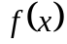 at the dyadic scale and at the location is defined to be
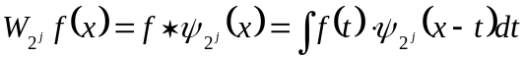.
The dyadic wavelet transform is then the sequence of functions
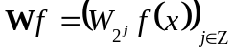,
and  is the dyadic wavelet transform operator.
Let the Fourier transform of 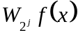 be denoted as 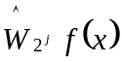. Then, we have
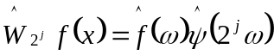.
If there exist positive constants 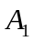 and 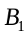such that for 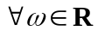
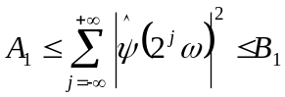,
then the whole frequency axis is covered by dilations of 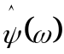 by 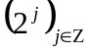 so that 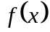 can be recovered from its dyadic wavelet transform. The reconstruction wavelet is any function 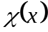 whose Fourier transform satisfies the property
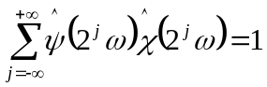.
The function is recovered from its dyadic wavelet transform with the infinite summation
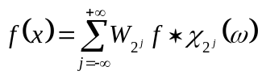
Equation 1 - Reconstruction formula
Any sequence 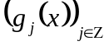 with 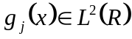 is not necessarily the dyadic wavelet transform of some function in 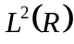. Let the inverse dyadic wavelet transform operator be denoted by 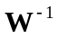 and defined as
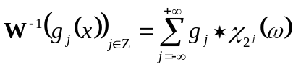.
The reconstruction formula (Equation 1) implies that is the dyadic wavelet transform of some function in if and only if
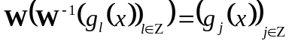.
Equation 2 – Condition for sequence of functions to be dyadic wavelet transform of function

Implementation of Discrete Dyadic Wavelet Transform
Mallat’s and Zhong’s paper included pseudo-code to implement the dyadic discrete wavelet transform. At each dyadic scale , the code decomposes the input into detail coefficients 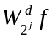and approximation coefficients 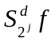. Detail coefficients correspond to high frequency information and contain the edge and edge type information whereas approximation coefficients correspond to low frequency information.
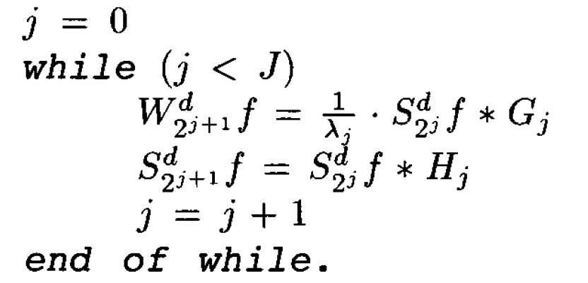
Figure 8 – Pseduo-code for discrete wavelet transform [1]
is the total number of decomposition levels which is limited by the length of the input signal. and are discrete filters that characterize the mother wavelet . is a low-pass filter whereas is a high-pass filter.

N | H | G | K
-3 |  |  | 0.0078125
-2 |  |  | 0.0546875
-1 | 0.125 |  | 0.171875
0 | 0.375 | -2.0 | -0.171875
1 | 0.375 | 2.0 | -0.0546875
2 | 0.125 |  | -0.0078125
3
Table 1 - Finite impulse response of filters that correspond to Quadratic Spline wavelet

Table 1 contains impulse responses for and . The impulse response of is convolved against the signal to produce the approximation coefficients whereas the impulse response of is convolved against the signal to produce the detail coefficients .
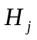 and 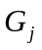 are upsampled versions of the original filters with 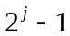 zeros inserted between each coefficient. The convolution operator is denoted by the symbol . Edge artifacts caused by discrete convolution are minimized by using periodic symmetric padding. The wavelet extrema of a step edge ought to have same value at all dyadic scales but due to discretization it does not. The constants 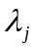 compensate for this effect.
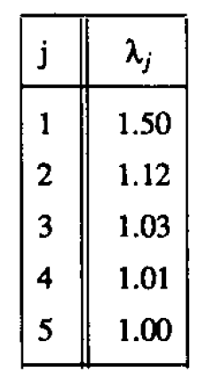
Table 2 - Normalization coefficients for quadratic wavelet. For j>5, =1 [1]
The code is initiated by setting 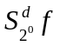 equal to the original input signal.
The three filters , , and 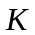 are related via the “perfect reconstruction property” given in [1] by the equation
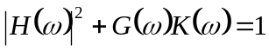
Equation 3 - Perfect reconstruction property
The implementation differs from the Mallat’s and Zhong’s approach in two ways:
- is set to 1 for all e.g. we do not compensate for step edge wavelet extrema.
- Convolution is implemented using circular convolution. This implies the input signal is periodically padded rather than symmetrically padded. This leads to false edges near boundary points. See results section for further details.

Save only local extrema
Mallat’s and Zhong’s algorithm saves only the local extrema of the detail coefficients and discards all other information, including all the coarse coefficients .
Assuming the length N of the input is a power of two, the wavelet transform is performed until log2(N) levels. In this case, the final coarse coefficients is exactly the mean of the original signal. Thus the coarse coefficients can all be discarded.
Local extrema are values whose magnitude are greater than or equal to the magnitude of its two neighbours and whose magnitude is also strictly greater than at least one of its neighbor’s magnitude. The end points at each dyadic wavelet level are also saved so that the end intervals can be interpolated.
A compression strategy is achieved if the number of values saved is smaller than the number of values of the original signal. In the showcase example, the input signal has 256 values. The dyadic wavelet transform, a redundant representation of the original signal, is taken at 9 different scales with each scale having 256 values for a total of 2304 values. Only the local extrema, approximately 70 values, are saved.

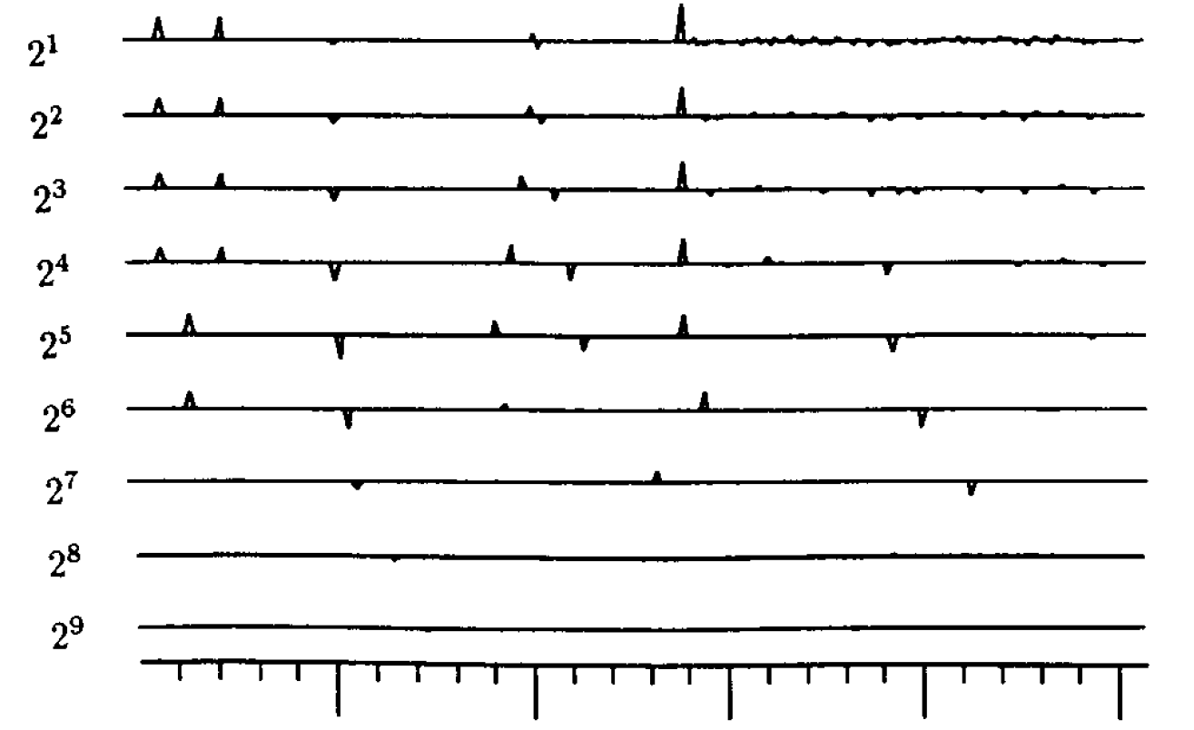
Figure 9 - Each dirac corresponds to a local extrema of the wavelet transform [1]

Apply method of alternate projections
After the previous step, we are left with only the values and locations of the local extrema of the wavelet transform at different scales. The method of alternate projections searches for a wavelet transform that is similar to the original signal’s wavelet transform.
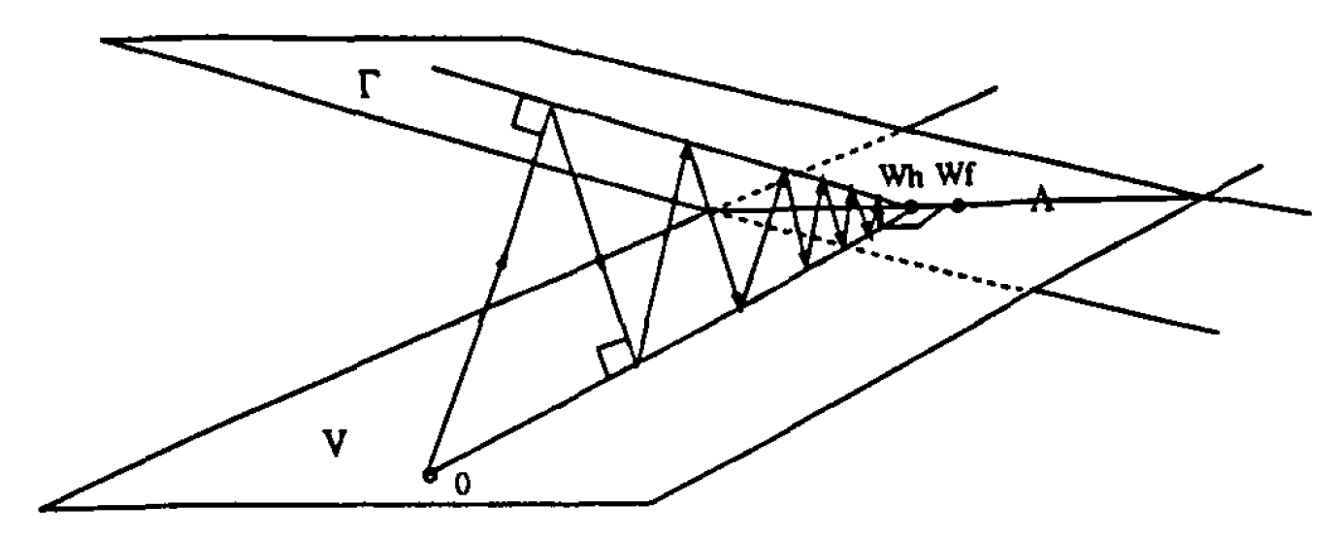
Figure 10 - Method of alternate projections [1]
Let 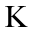be the space of all sequences of functions 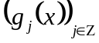such that
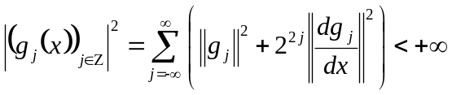
This norm defines a Hilbert structure over . The norm is a sum of weighted 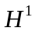 norms where
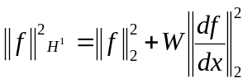
and where the weight factor 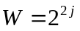 .
Let be the space of all dyadic wavelet transforms of functions in 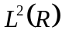 which can be shown to be included in . Let be the affine space of sequences of functions 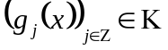such that for any index and extrema positions 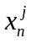
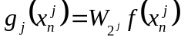
In other words, is the space of sequences of function in that interpolate the original signal’s dyadic wavelet transform at all extrema points and at all scales. It can be shown that is closed in . Then, 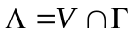, are wavelet transforms of functions that interpolate the extrema points at all scales. We seek the minimal element in 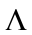with respect to the norm for so that the interpolated points behave as local extrema. To find this minimal element in , we apply the method of alternate projections.
Let denote the dyadic wavelet transform and 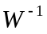denote the inverse dyadic wavelet transform as defined in Section 2.1. Equation 2 implies that any dyadic wavelet transform is invariant under the operator
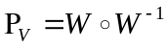,
which means 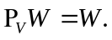The operator 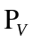 takes the inverse dyadic wavelet transform followed by the dyadic wavelet transform. For any sequence 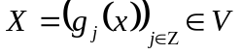, 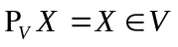. Therefore, the operator is the orthogonal projection onto , the space of all dyadic wavelet transforms of functions.

The operator 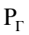 projects any sequence into the closest sequence in 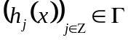 with respect to the norm for . The operator is implemented by adding piecewise exponential curves to each function of the sequence that is projected on .

To elaborate, let the error between an element in the ambient space and an element in , the space of sequences of functions that interpolate the original signal’s wavelet transform, be denoted as
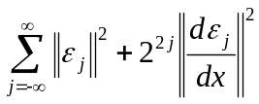
Equation 4 - Error between an element in and element in
where
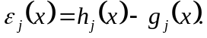
The error is a sum of weighted norms (Sobolev norm with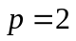, 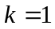) of the error for each dyadic scale where the weighting factor is 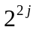. In other words, the error is measured with respect to the norm of the ambient space. We wish to find 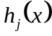 such that this error is minimum, thereby projecting the given element of to the closet element in . To minimize this sum, we minimize separately each component
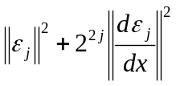
Let 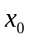 and 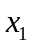 be the locations of two consecutive local extrema of 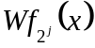, the wavelet transform of the original signal at dyadic scale . Since , the space of sequence of functions that interpolate the original signal’s wavelet transform extrema, we have
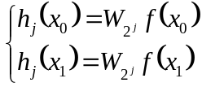
which implies
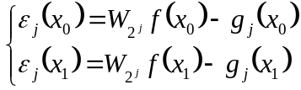
Equation 5 - Border conditions
Between the local extrema locations and , the minimization of the error (Equation 1) between an element in and an element in is equivalent to the minimization of
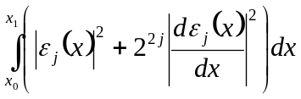
From the theory of calculus of variations, the Euler equation for this minimization is
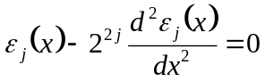,
for 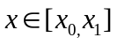whose solution is given by a sum of two weighted exponentials
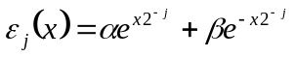
Equation 6 - Minimal error that satisfies border conditions for dyadic scale
The coefficients and  satisfy the border conditions of Equation 2. Therefore, using Equation 2 and 3, we can solve for the coefficients by inverting a 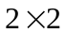 matrix:
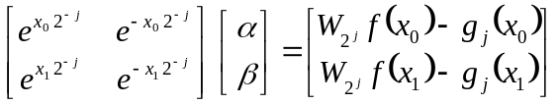
At each dyadic scale and between every pair of locations of local extrema, and , the operator adds to the function 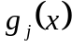 , 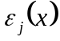 which is a function of six arguments, , , 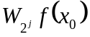, 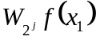, 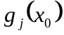, and 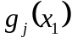 . By doing so, projects into the closest sequence in with respect to the norm for .
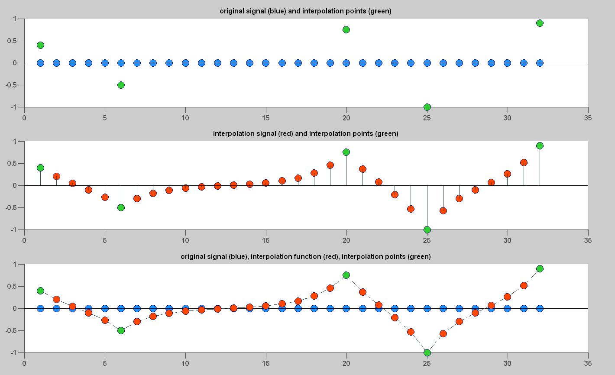
Figure 11 - Projection onto space of zero function for a given
Let 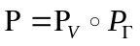be alternate projections on both spaces and let 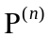be iterations of the operator . Since is an affine space and a Hilbert space, a classical result on alternate projections [2] proves that for any sequence of functions 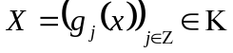,
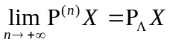
In other words, alternate projections on and V converge to a projection onto the desired solution space for any starting point 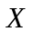in the ambient space . If is the zero element of , that is 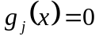 for all 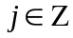, then the alternate projections converge to the element of whose norm is minimum, thus making the interpolations points that specify the space act like local extrema.

Take inverse dyadic wavelet transform
After a desired number of iterations of alternate projections, an approximation of the original signal’s wavelet transform has been found. The signal is reconstructed by then taking the inverse dyadic wavelet transform.
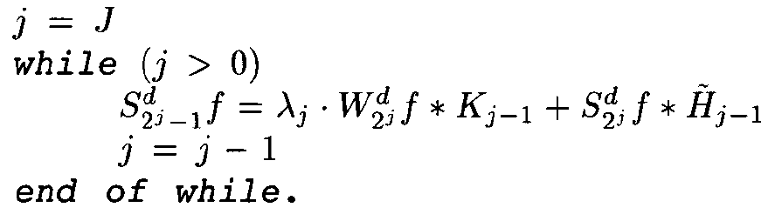
Figure 12 – Pseudo-code for inverse dyadic wavelet transform [1]
is the total number of decomposition levels which is limited by the length of the input signal. and are discrete filters that characterize the mother wavelet . 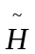is the complex conjugate of . See Section 2.1 for further details.

Implementation
MATLAB is used to implement the signal reconstruction algorithm. Only built-in MATLAB functions are used, and no extra toolboxes are needed.
The dyadic wavelet transform and inverse dyadic wavelet transform are implemented using the pseudo-code provided in Mallat’s and Zhong’s paper [1] with the modifications described in Section 2.2.

Databases
The database consists of baseline signals and audio signals. Baseline signals include signals with different types of edges: sinusoids, diracs, step edges, and Gaussians. Audio signals consist of different speech samples.

Validation
There are five main components of the algorithm: the dyadic wavelet transform (DWT), the local extrema search, the projection, the projection, and the inverse dyadic wavelet transform (IDWT). Each component is validated with different tests.

DWT/IDWT Perfect Reconstruction Test
To test that both the DWT and IDWT are coded correctly, the DWT/IDWT Perfect Reconstruction Test is applied.
The test is simple: for any given input, take the DWT followed by the IDWT. The input should then be recovered perfectly up to machine precision.
If the code passes this test, this would then imply that the DWT and IDWT were coded correctly, and the projection onto the V space is performed correctly.
The code passed this test at the end of November despite having two bugs, both subtle.
First, the IDWT reused all the original input’s coarse approximation coefficients rather than rebuilding each level’s coarse approximation coefficients from the previous level’s detail and approximation coefficients. This bug allowed the code to pass the test since only the 1st level’s approximation coefficients are ever used. The bug emerged when all the coarse approximation coefficients were zeroed out, and all details coefficients saved.
Second, Mallat’s and Zhong’s paper [1] contained a typo when specifying the coefficients of the Quadratic Spline filters. The 2rd coefficient of the synthesis K filter was given as 0.054685 instead of 0.0546875.
The code passed the test despite having this bug because the input signals were not of sufficient length.

Local Extrema Search Test
The local extrema search is tested by verifying that a given set of local extrema are correctly located.

Projection Test
The projection is tested by verifying that a given set of interpolation points are perfectly interpolated. Results are also visually examined to look for smoothness and minimization of the norm.

Testing
The algorithm was first tested against a variety of baseline signals. An initial exponential decay in l2 error versus the number of alternate projection iterations is observed for each base line signal.
The algorithm was then tested against an audio signal.

Step Edge (Length 32)
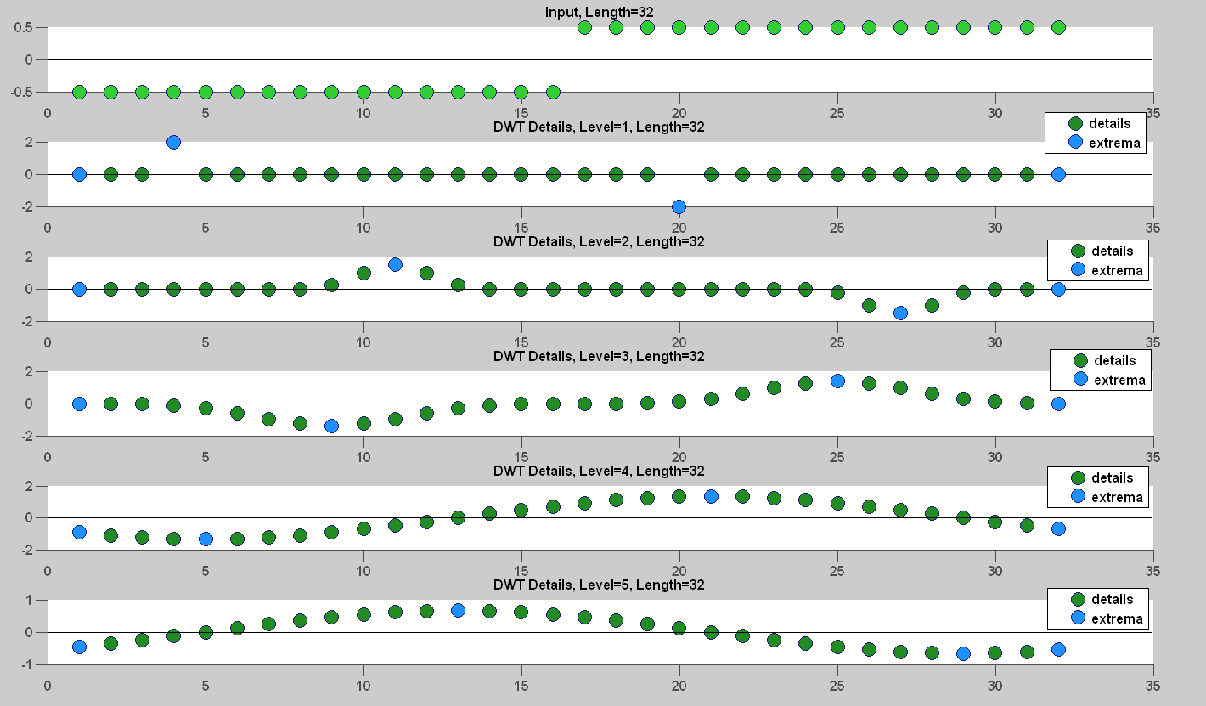
Figure 13 - Step Edge DWT with local extrema marked (20 extrema saved)
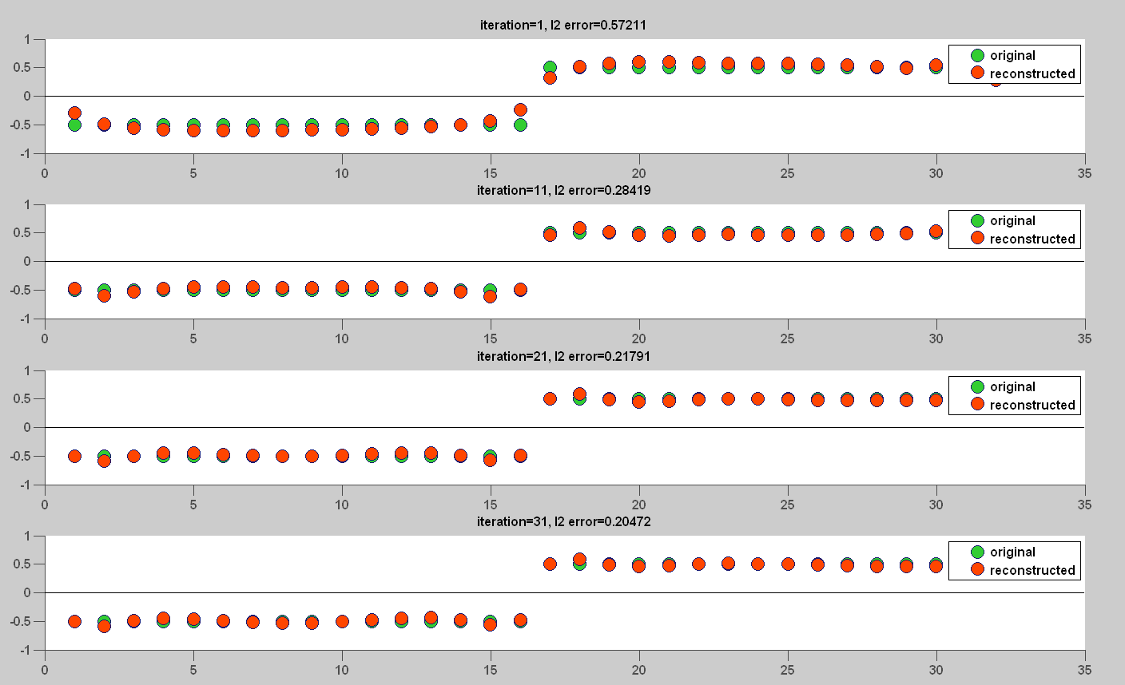
Figure 14 - Reconstructed Step Edge (iteration 1, 11, 21, 31)
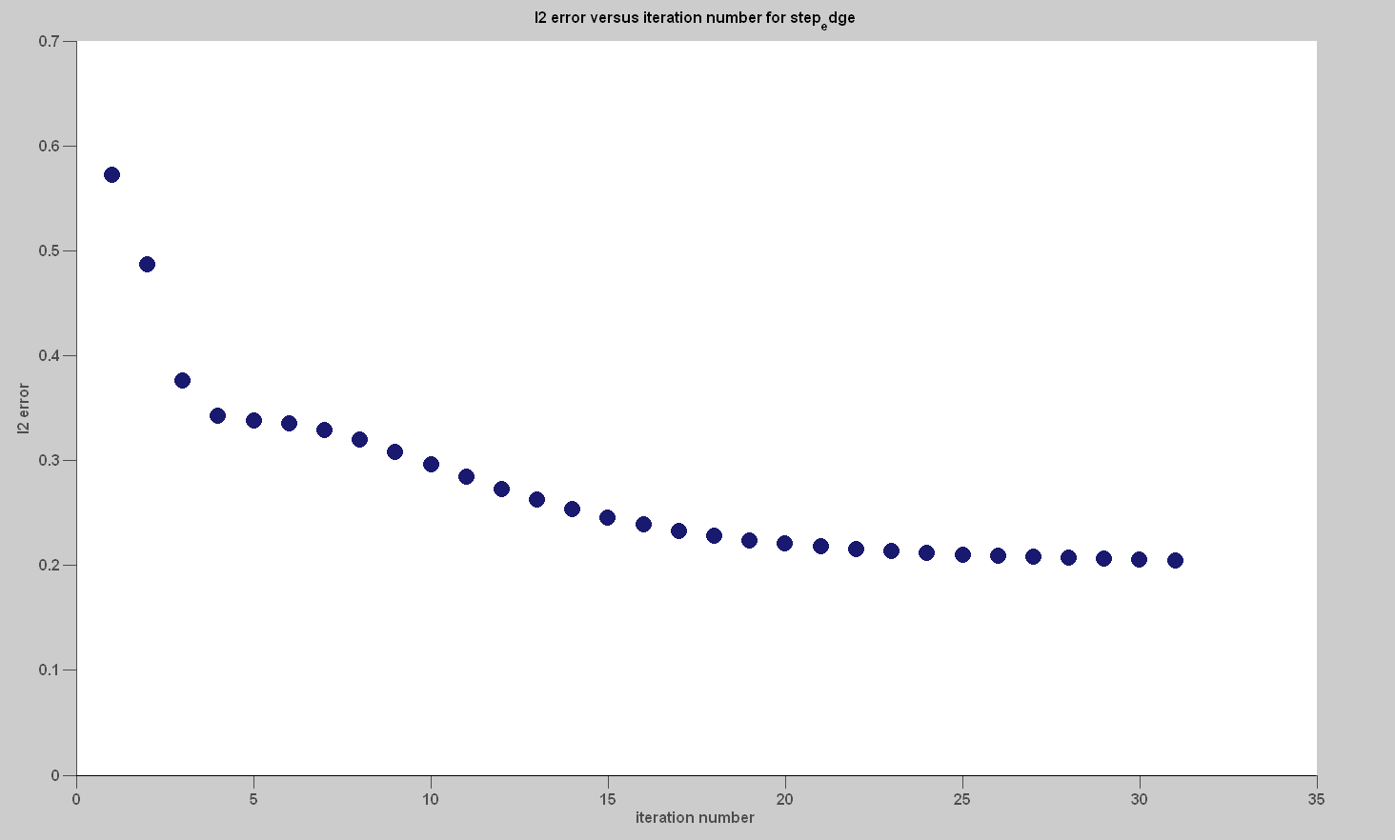
Figure 15 - l2 error versus iteration for Step Edge
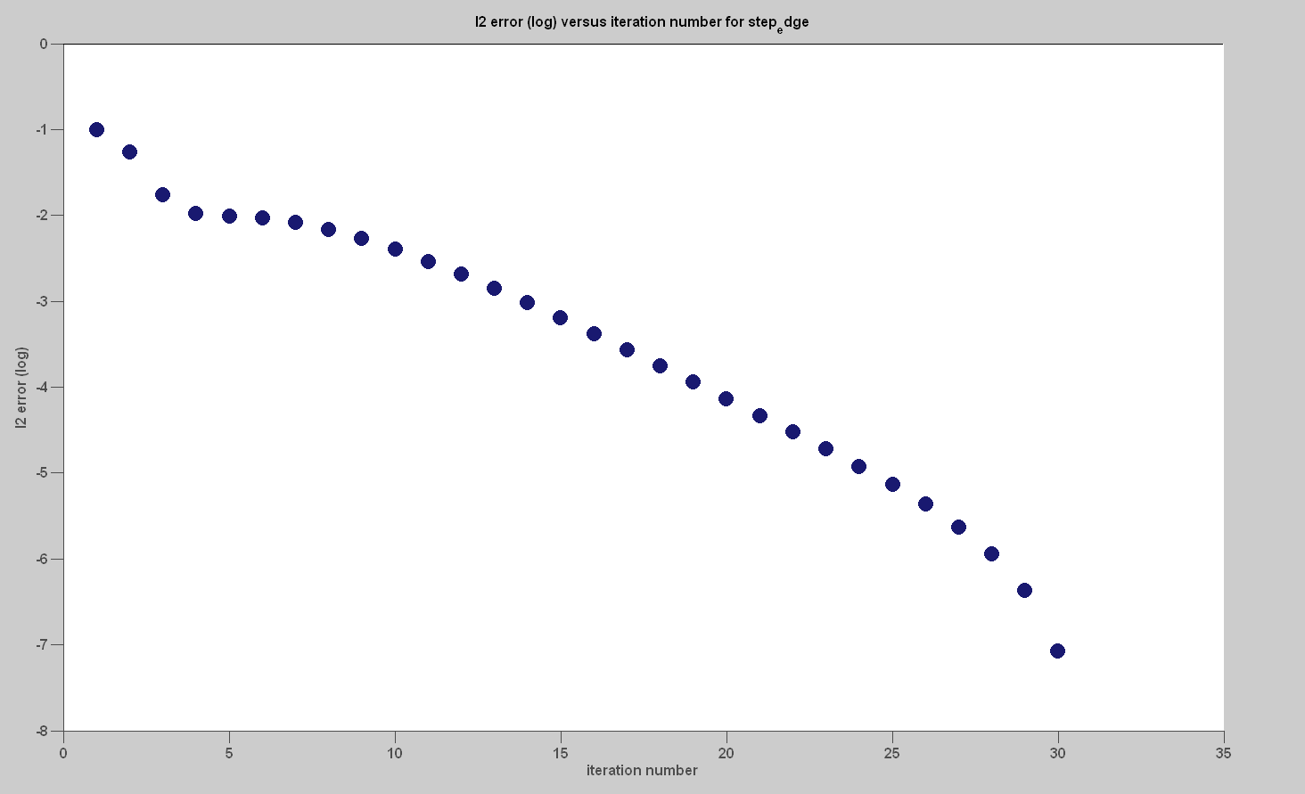
Figure 16 - log l2 error versus iteration for Step Edge

Gaussian (Length 32)
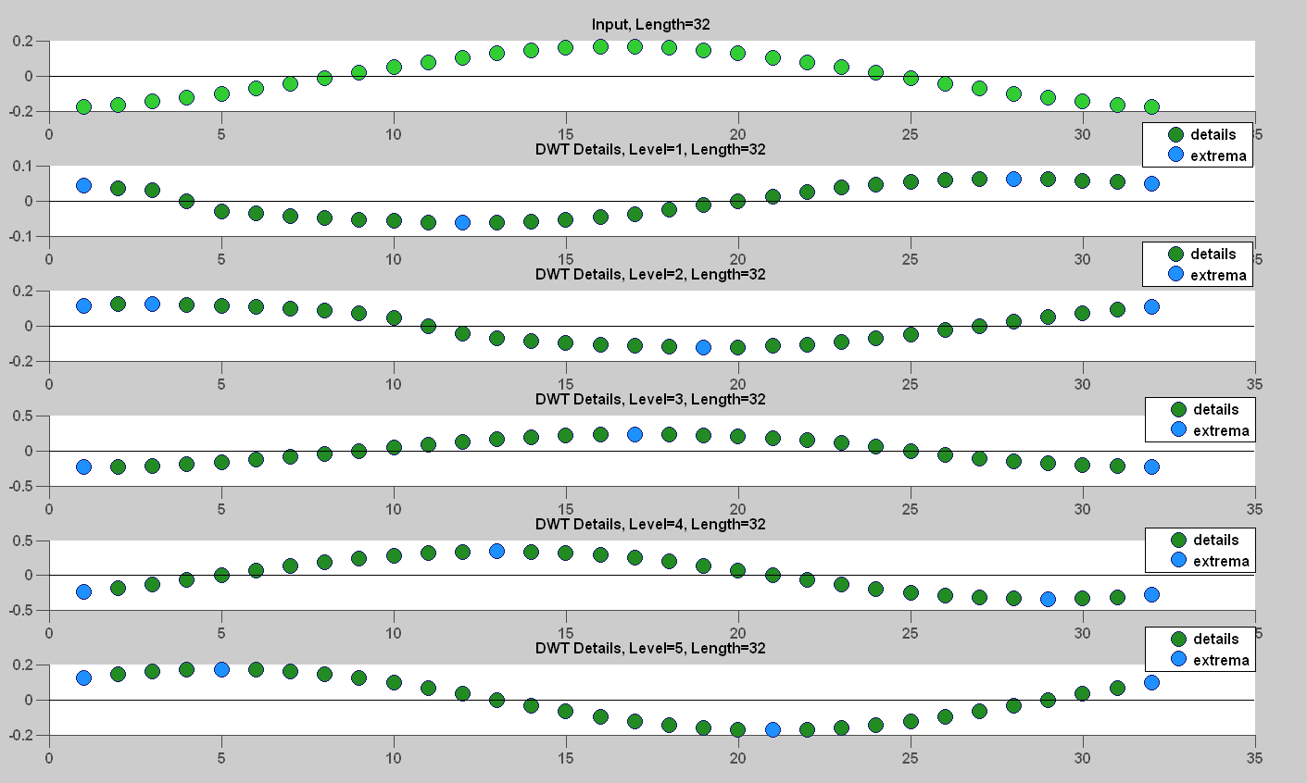
Figure 17 – Gaussian DWT with local extrema marked (19 extrema saved)
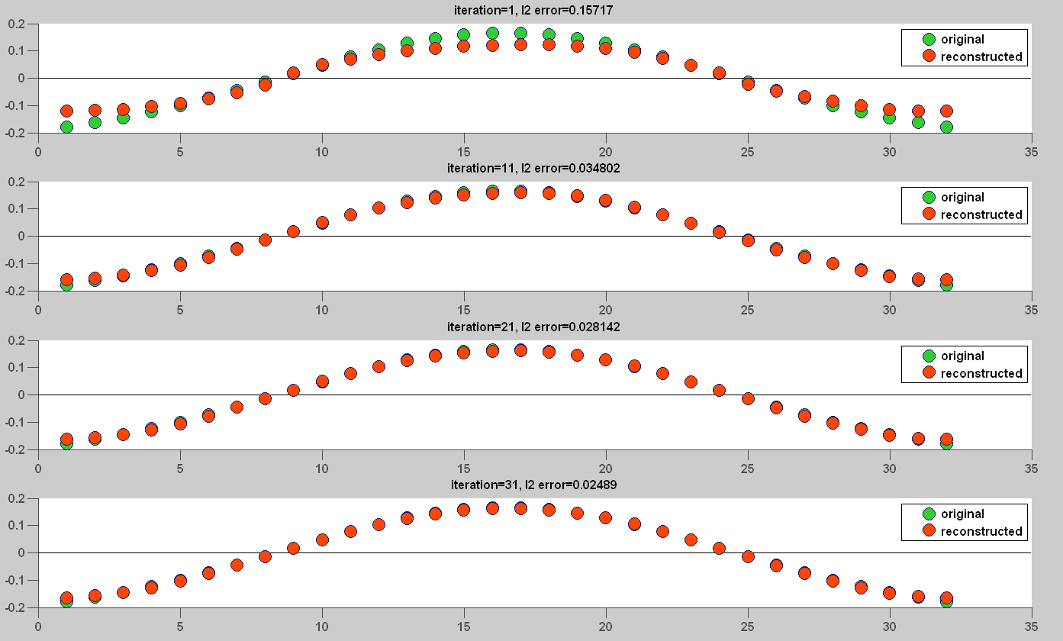
Figure 18 - Reconstructed Gaussian (iteration 1, 11, 21, 31)
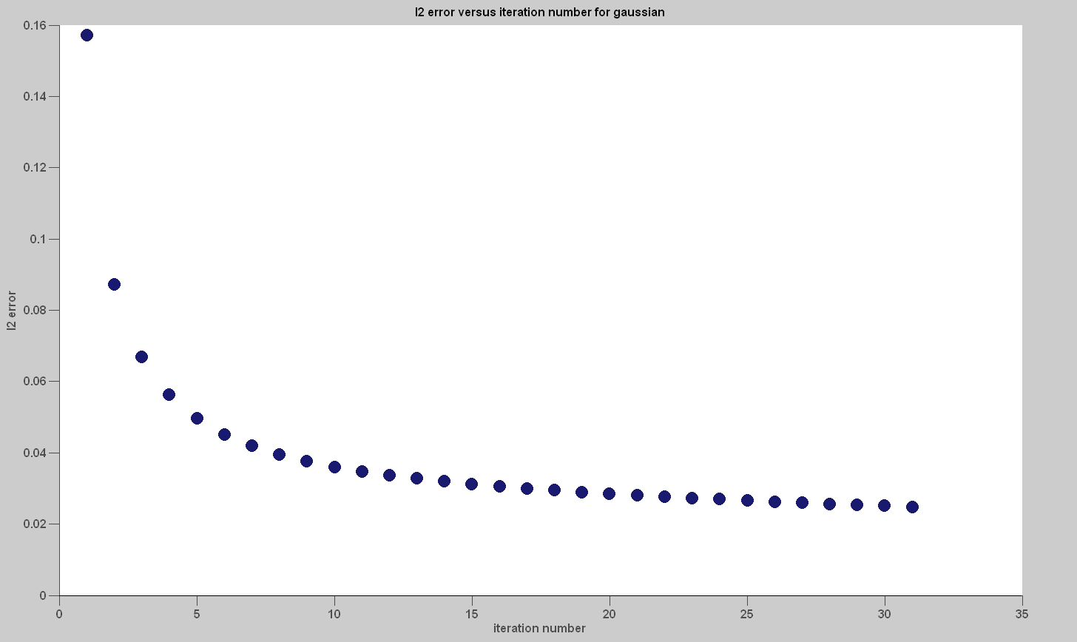
Figure 19 - l2 error versus iteration for Gaussian
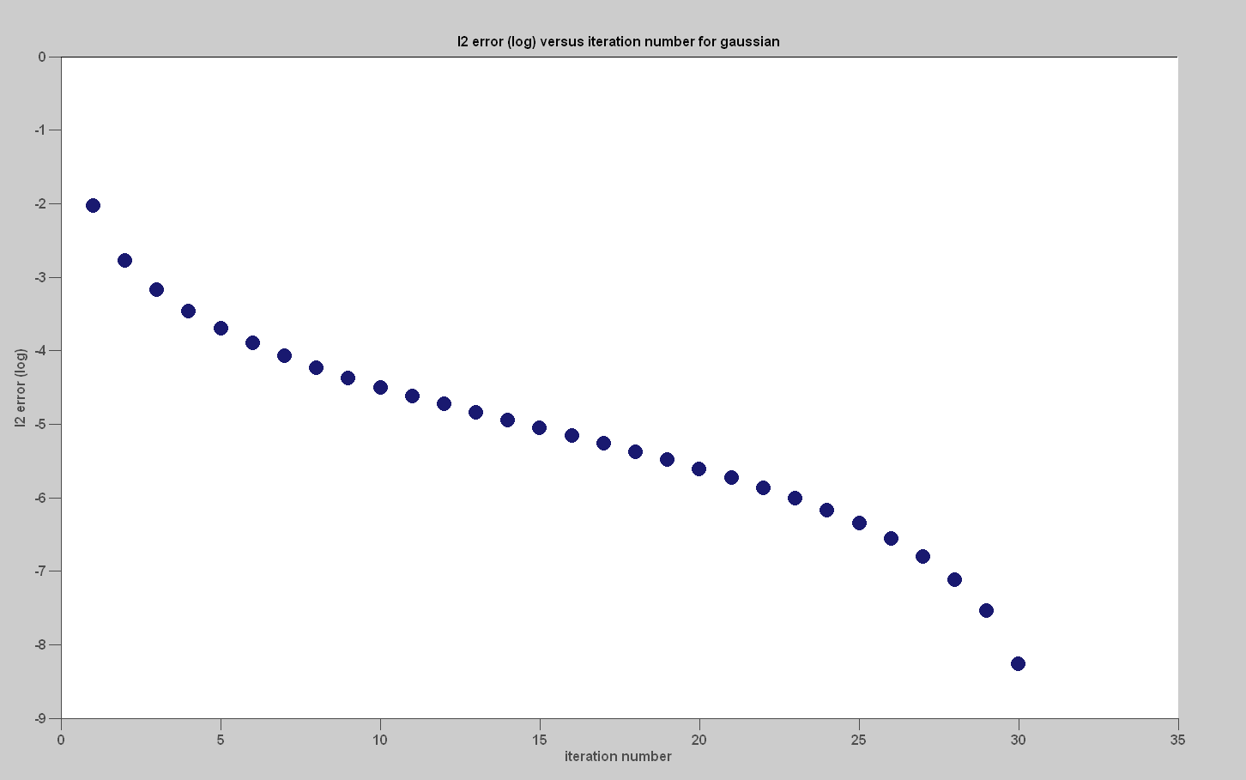
Figure 20 - log l2 error versus iteration for Gaussian

Dirac Delta (Length 32)
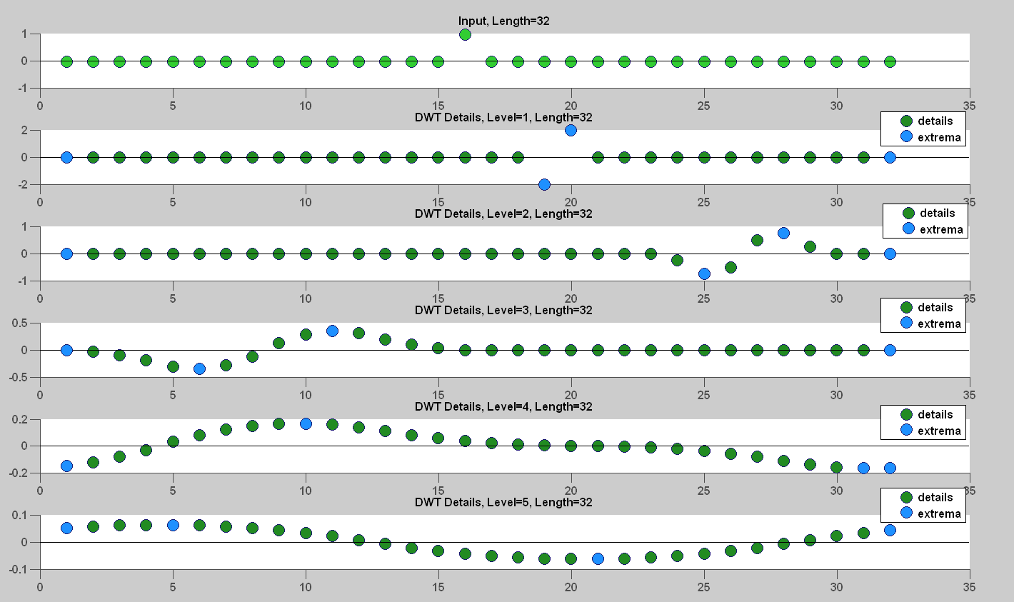
Figure 21 - Dirac Delta DWT with local extrema marked (20 extrema saved)
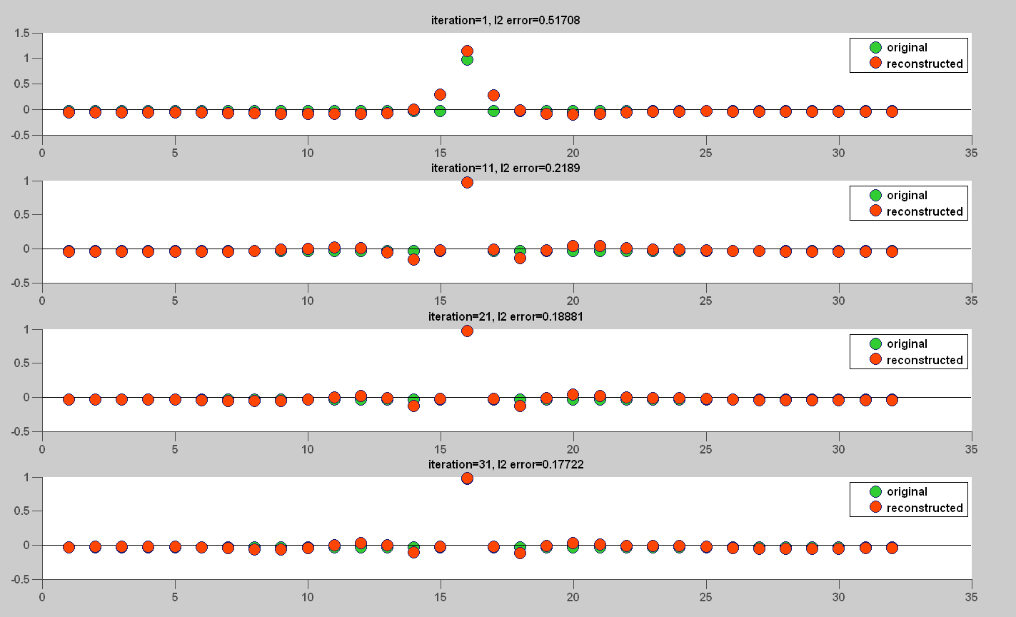
Figure 22 - Reconstructed Dirac Delta (iteration 1, 11, 21, 31)

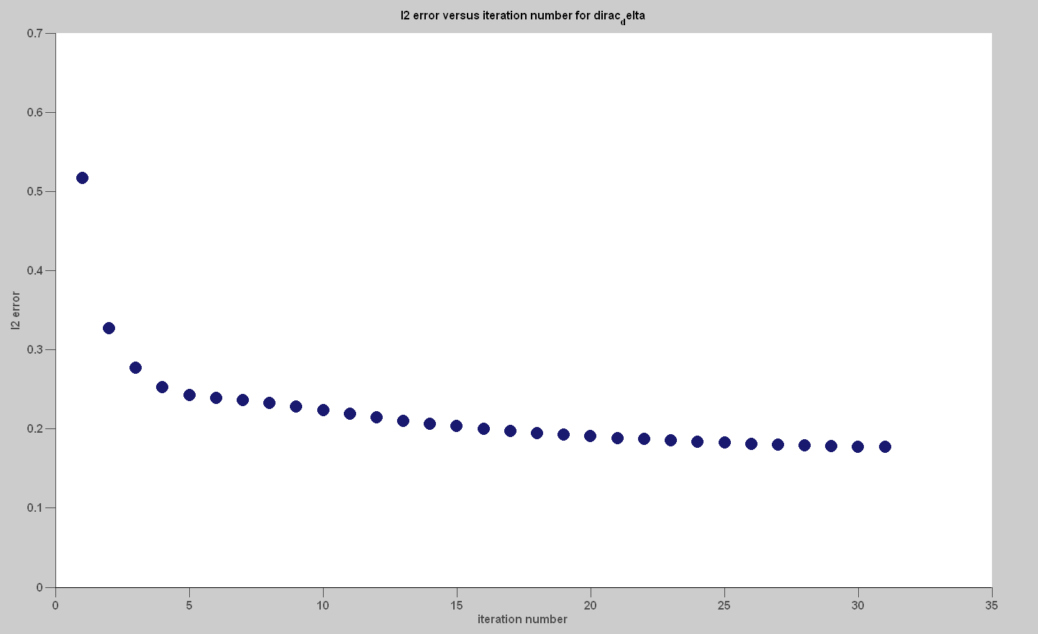
Figure 23 - l2 error versus iteration for Dirac Delta
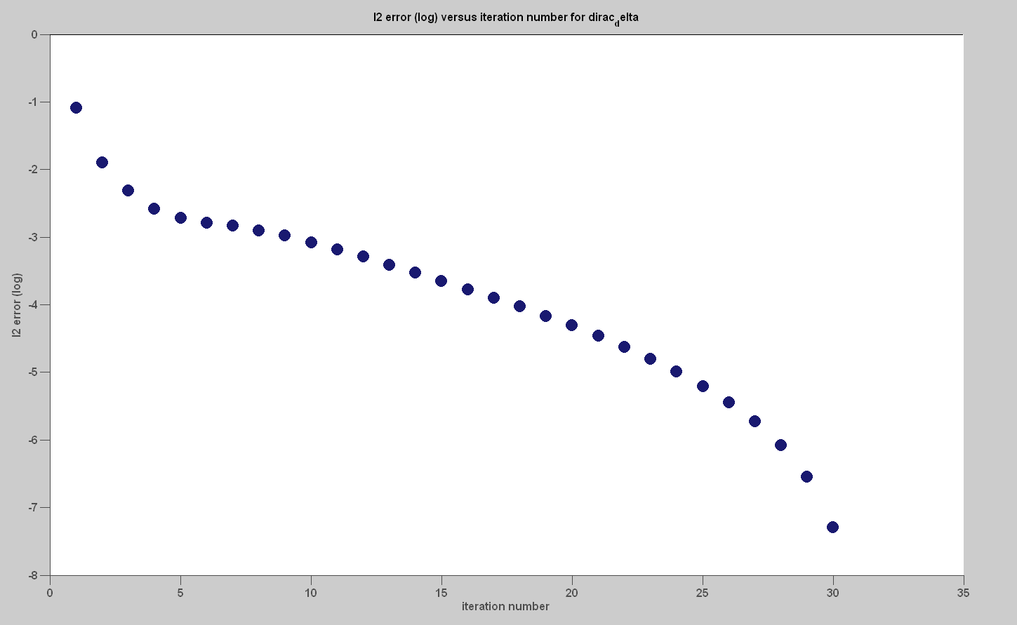
Figure 24 - log l2 error versus iteration for Dirac Delta

Sinusoid (Length 32)
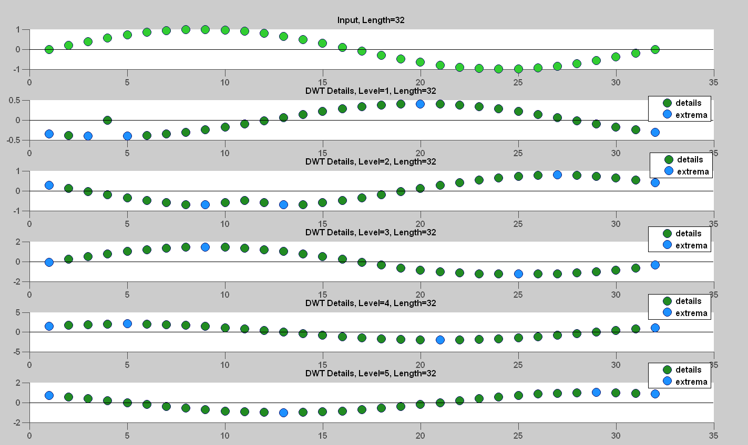
Figure 25 - Sinusoid DWT with local extrema marked (22 extrema saved)
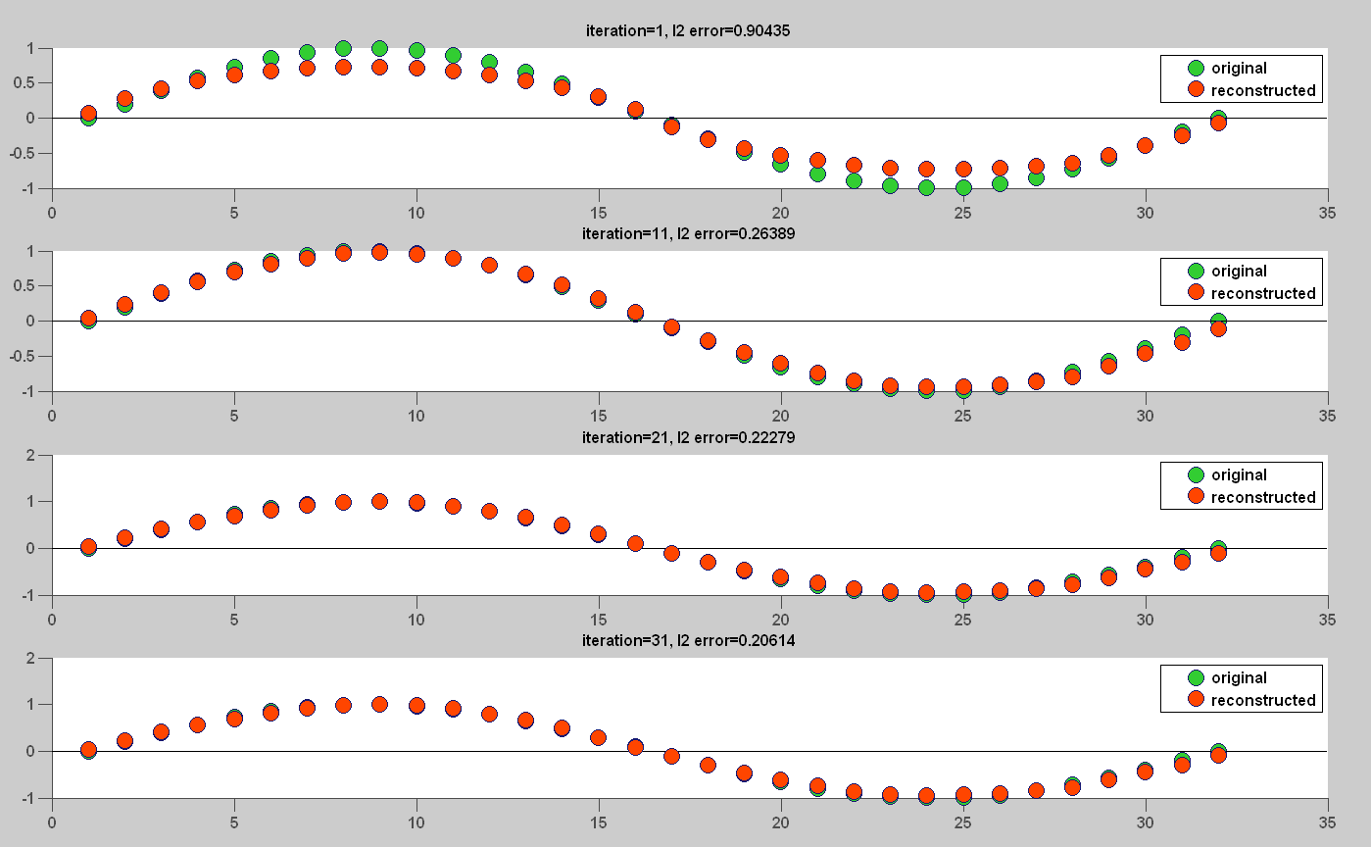
Figure 26 - Reconstructed Sinusoid (iteration 1, 11, 21, 31)
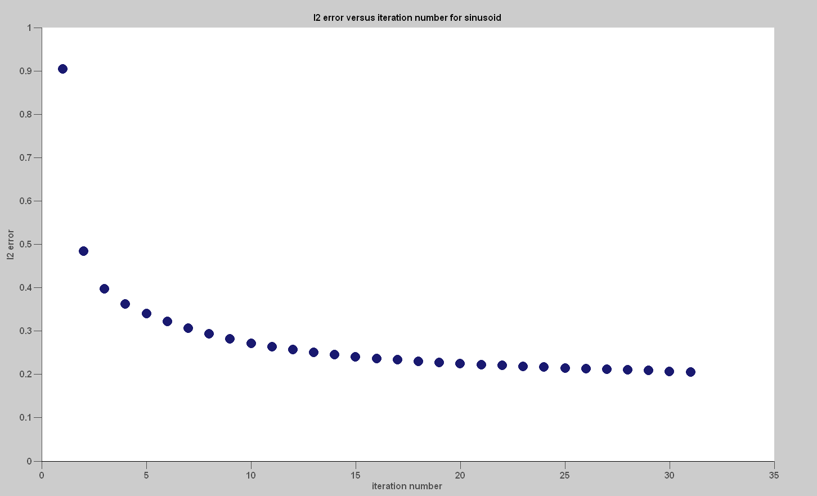
Figure 27 - l2 error versus iteration for Sinusoid
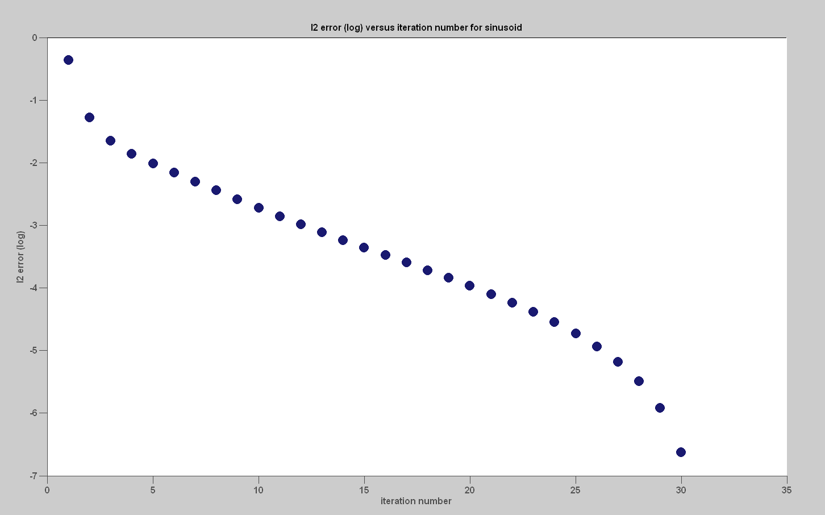
Figure 28 - log l2 error versus iteration for Sinusoid

Triangle (Length 32)
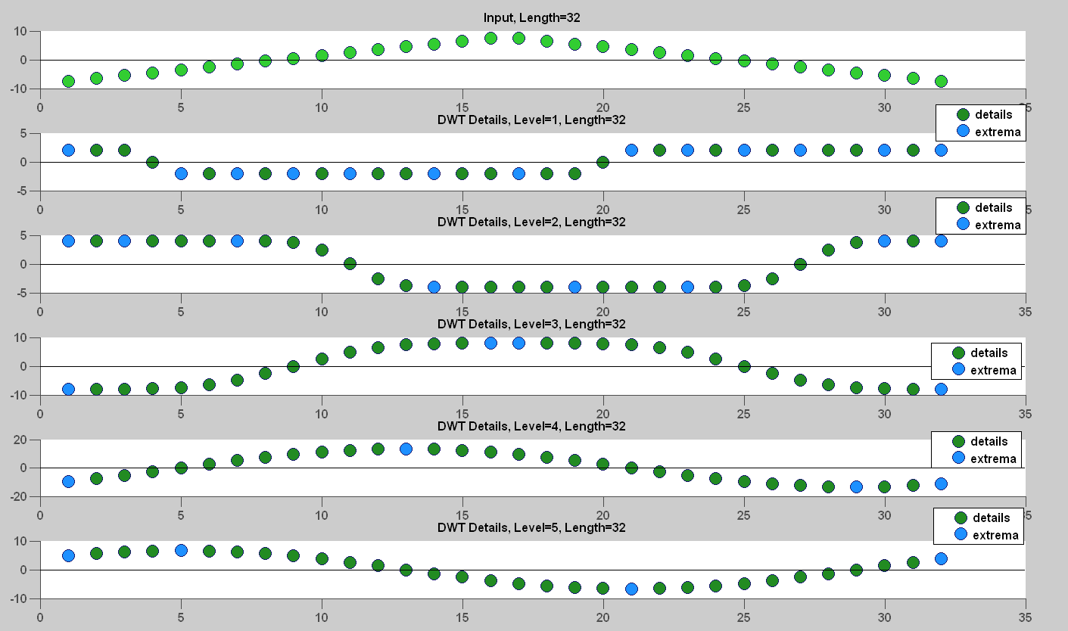
Figure 29 - Triangle DWT with local extrema marked (33 extrema saved)
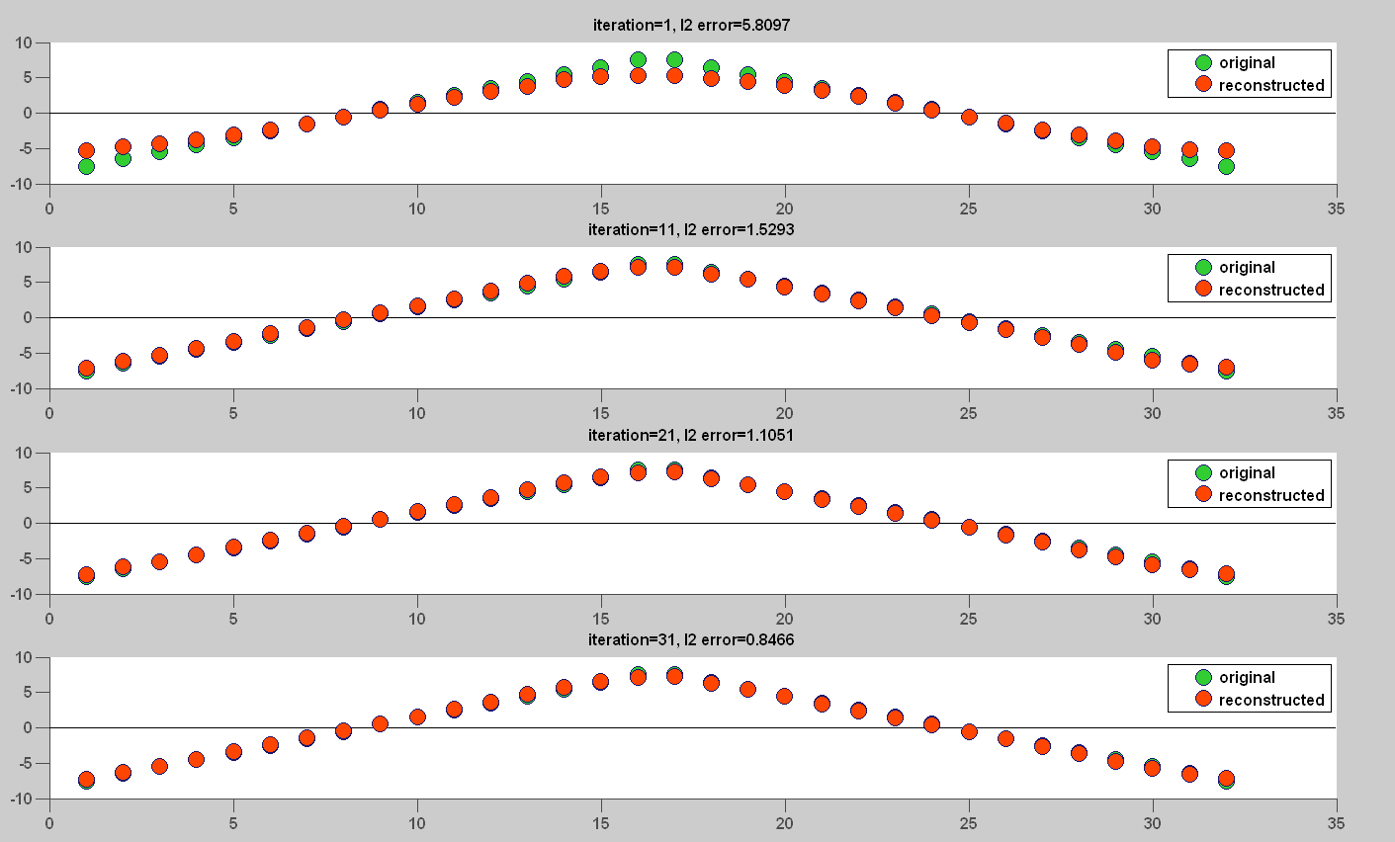
Figure 30 - Reconstructed Triangle (Iteration 1, 11, 21, 31)
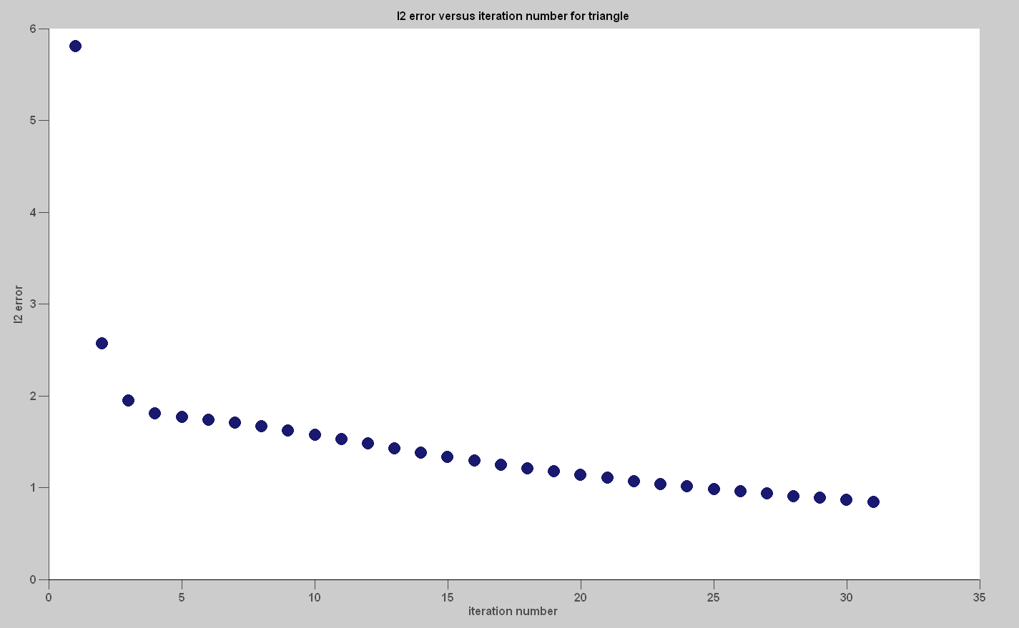
Figure 31 - l2 error versus iteration for Triangle
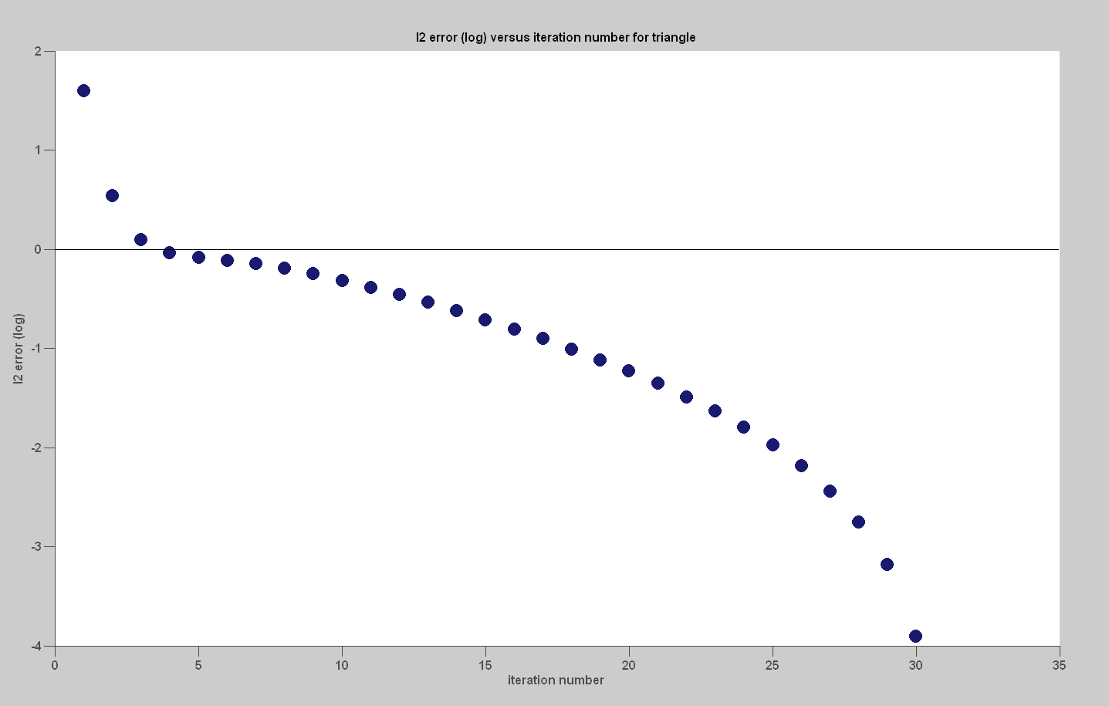
Figure 32 - log l2 error versus iteration for Triangle

Random Noise (Length 32)
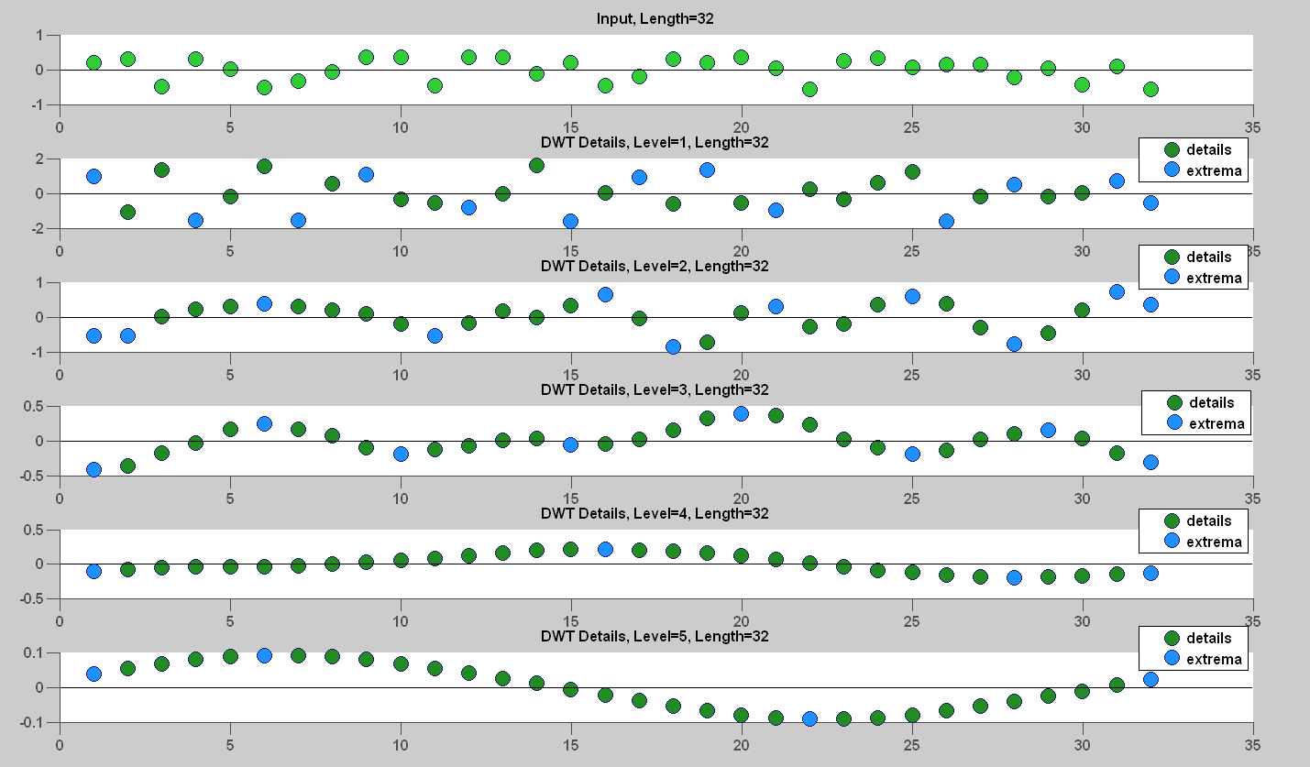
Figure 33 - Random Noise with local extrema marked (40 extrema saved)

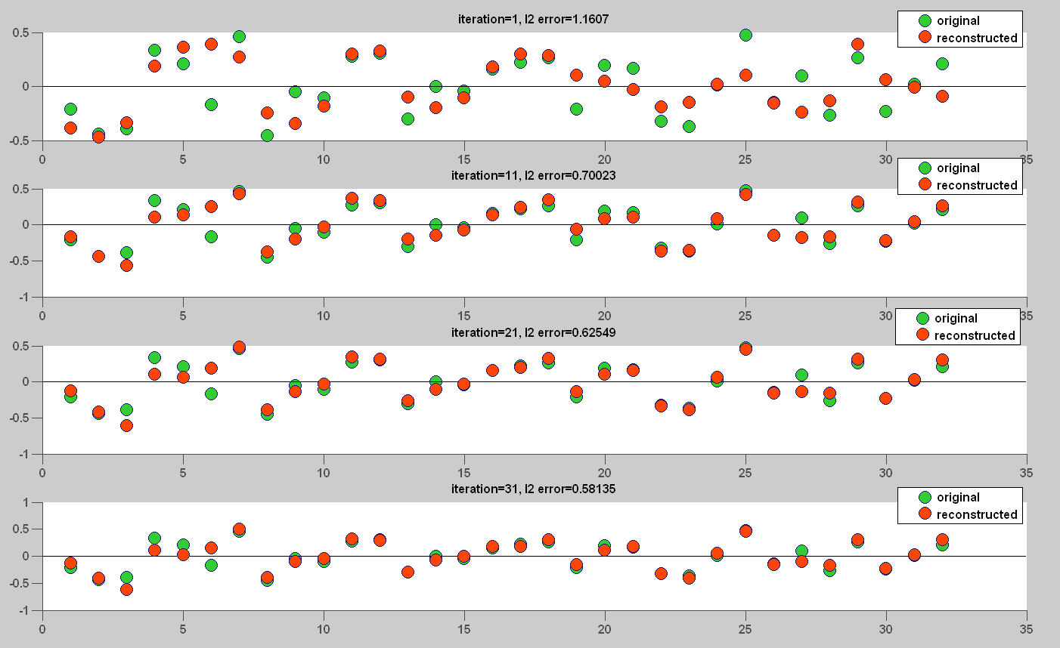
Figure 34 - Reconstructed Random Noise (iteration 1, 11, 21, 31)
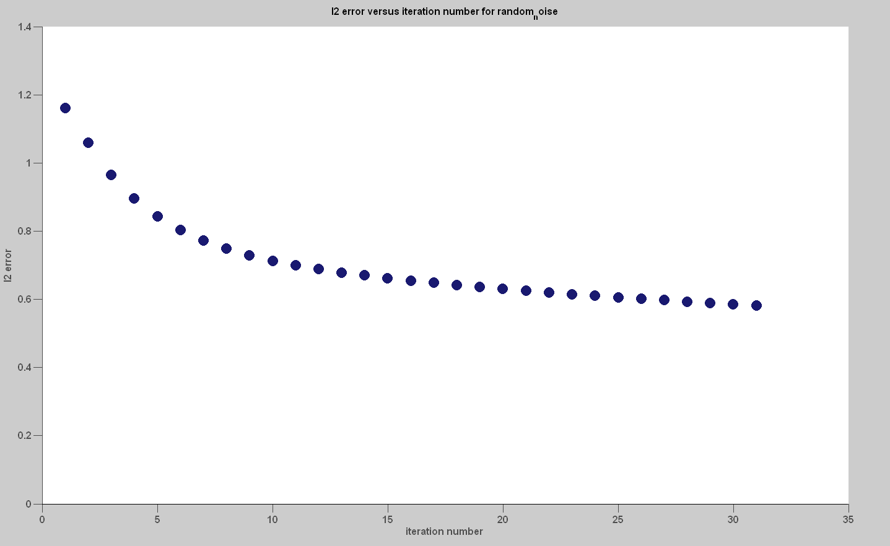
Figure 35 - l2 error versus iteration for Random Noise
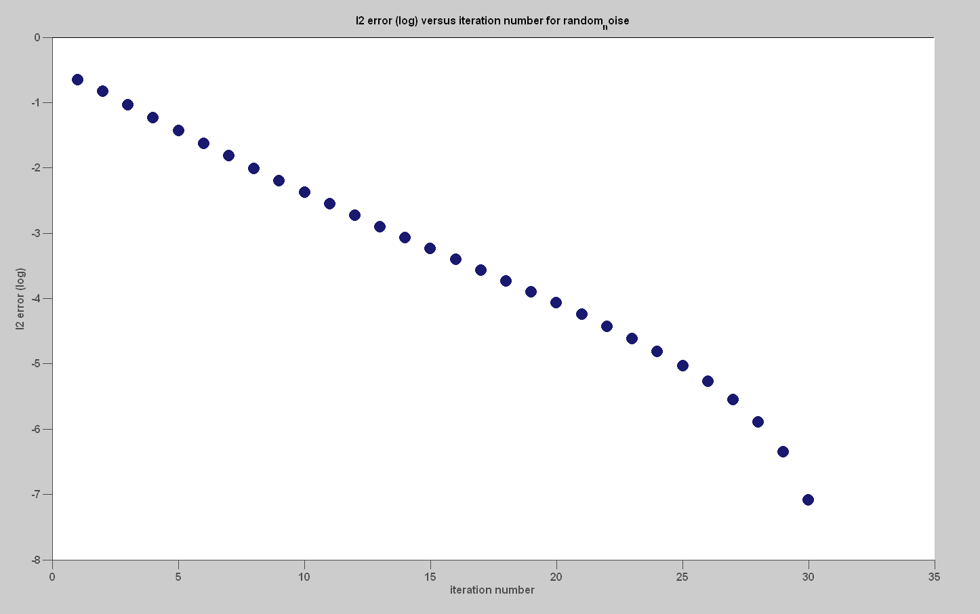
Figure 36 - log l2 error versus iteration for Random Noise

Audio Signal (Length 32,768)
The algorithm first broke the input into windows each of length 1024. A total of 31 alternate projection iterations was then performed on each window. An exponential decay in l2 error was again observed.
Window | Extrema | Window | Extrema | Window | Extrema | Window | Extrema
1 | 900 | 9 | 927 | 17 | 865 | 25 | 756
2 | 868 | 10 | 827 | 18 | 1081 | 26 | 781
3 | 877 | 11 | 841 | 19 | 889 | 27 | 841
4 | 846 | 12 | 830 | 20 | 916 | 28 | 947
5 | 779 | 13 | 826 | 21 | 995 | 29 | 920
6 | 787 | 14 | 875 | 22 | 870 | 30 | 293
7 | 760 | 15 | 770 | 23 | 955 | 31 | 20
8 | 776 | 16 | 757 | 24 | 847 | 32 | 20
Figure 37 - Extrema saved in each window (25,242 extrema saved)
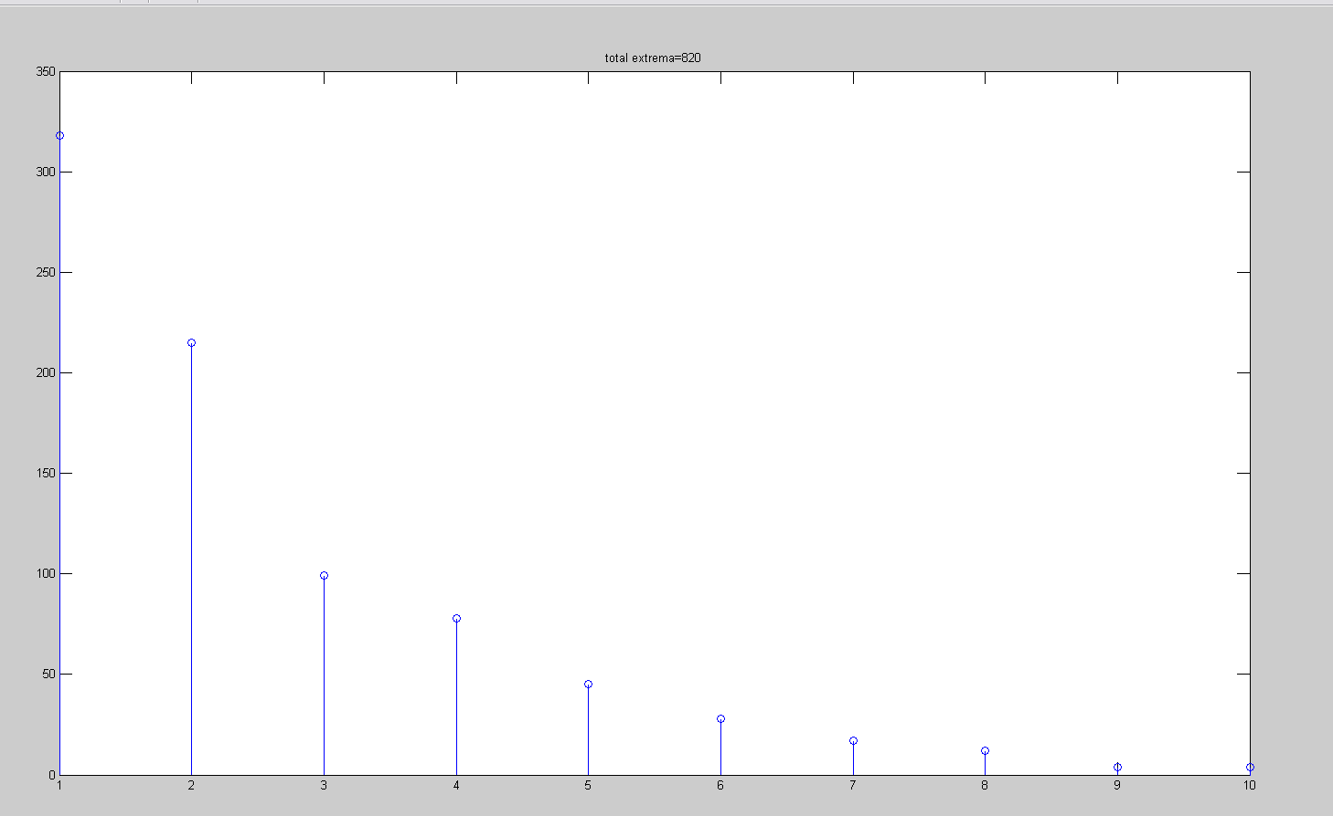
Figure 38 - Extrema saved by wavelet transform level for 10th window
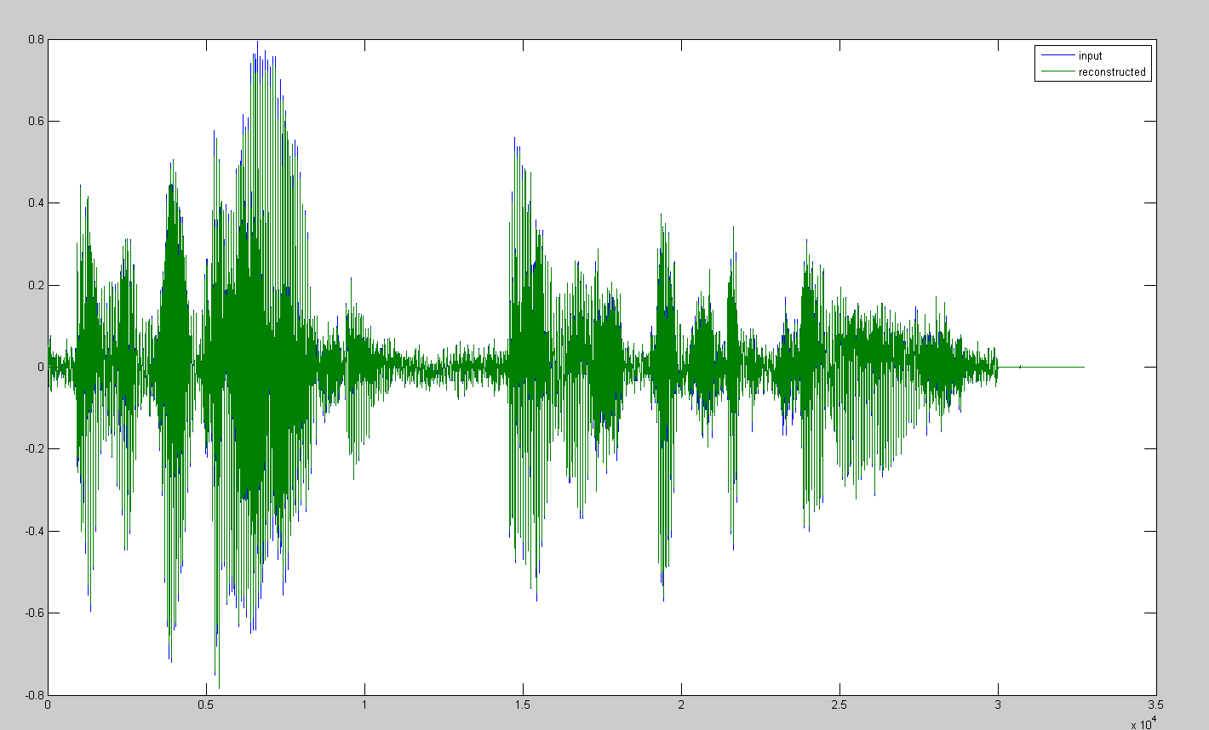
Figure 39 - Reconstructed audio after 31 iterations overlaying input audio (l2 error=2.53754), zoom plots from left to right below
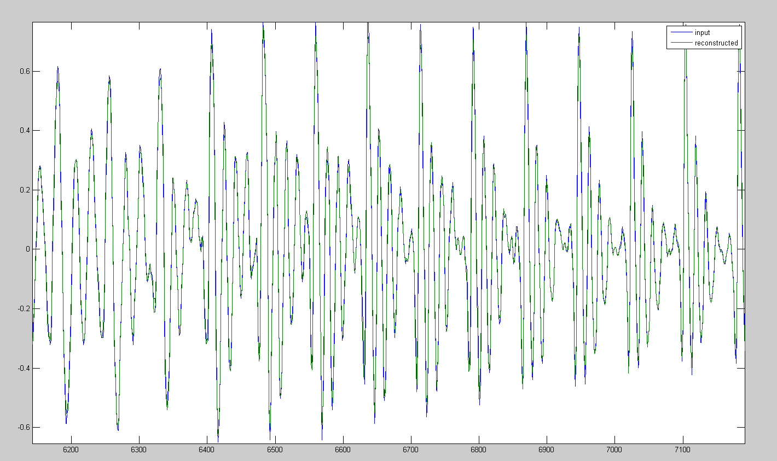
Figure 40 - Zoom 1
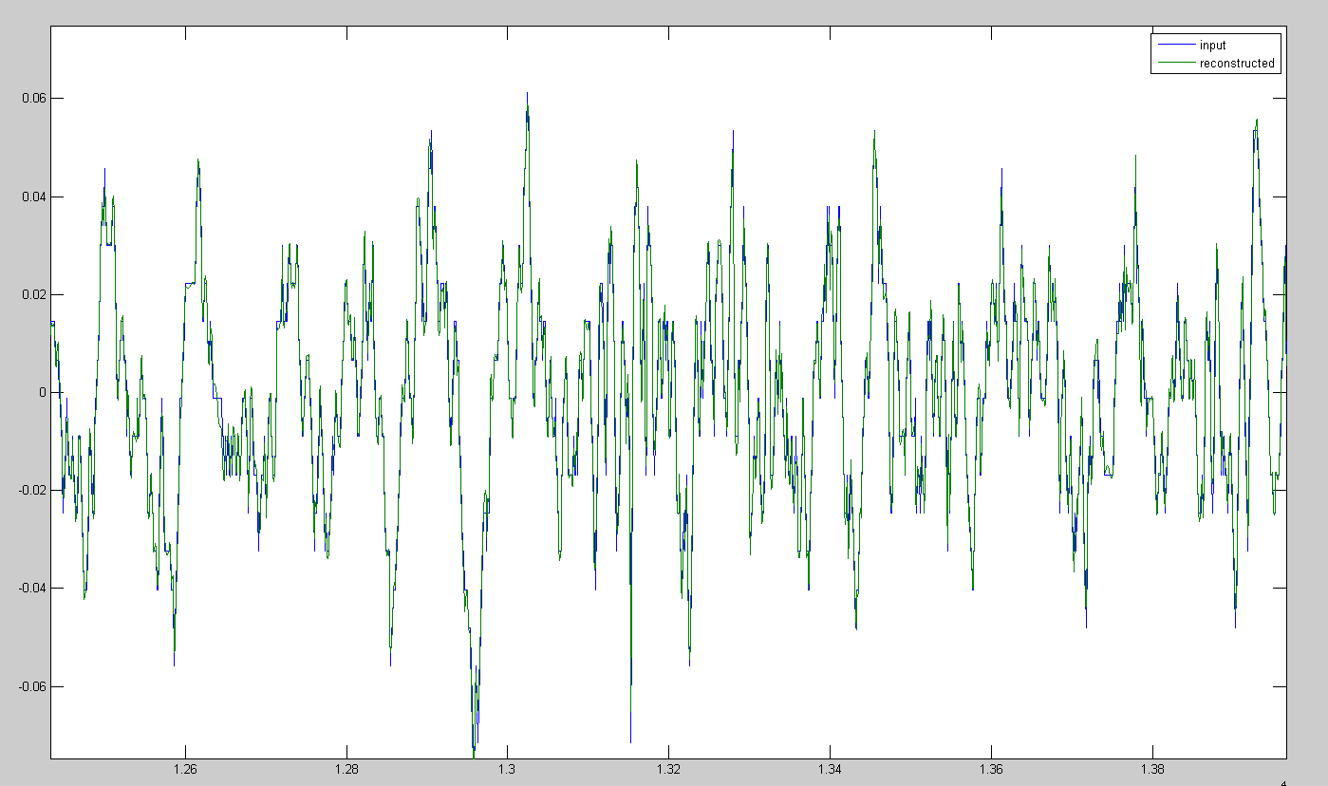
Figure 41 - Zoom 2
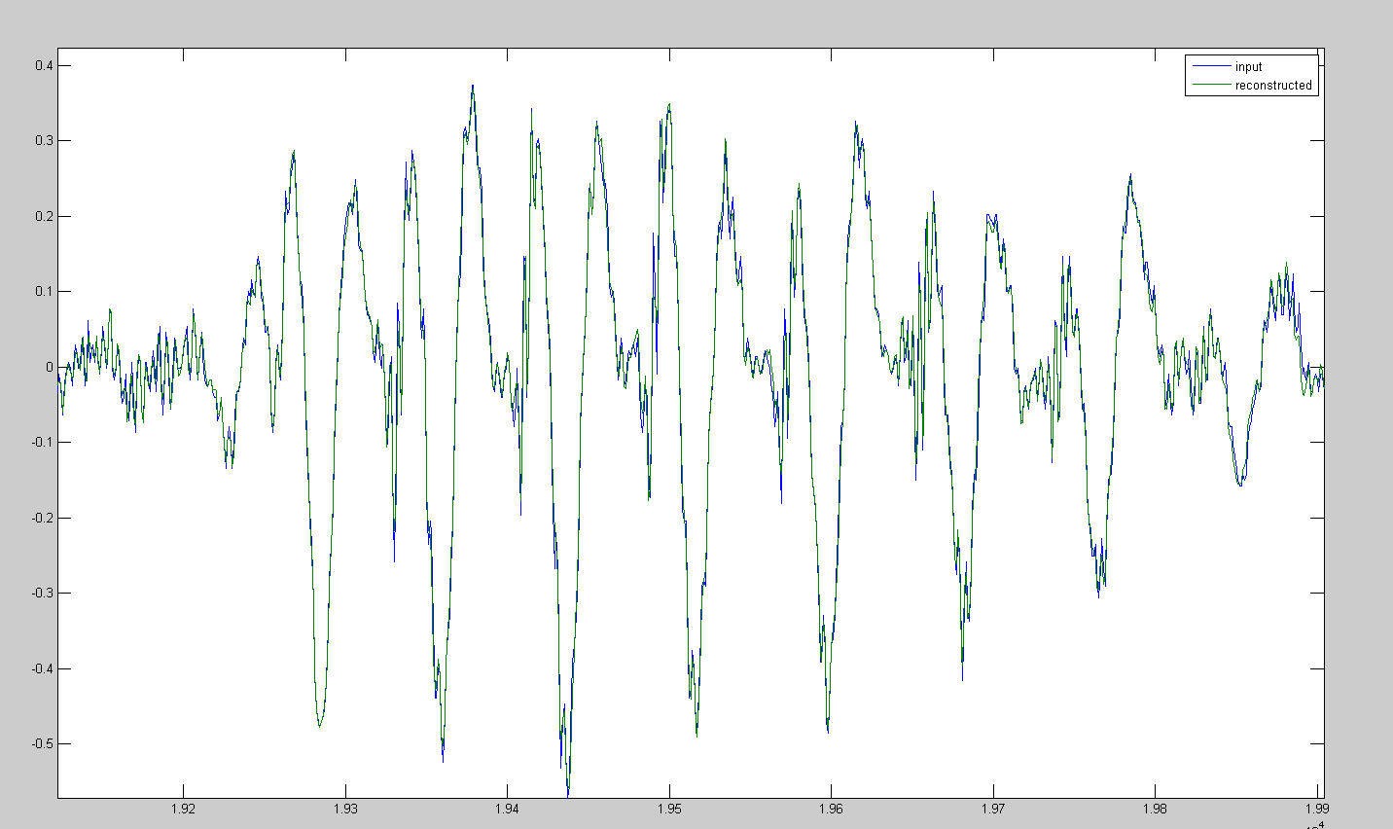
Figure 42 - Zoom 3
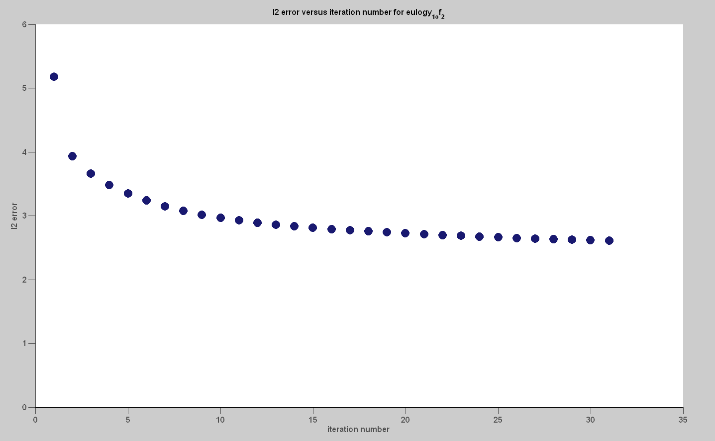
Figure 43 - l2 error versus iteration for audio
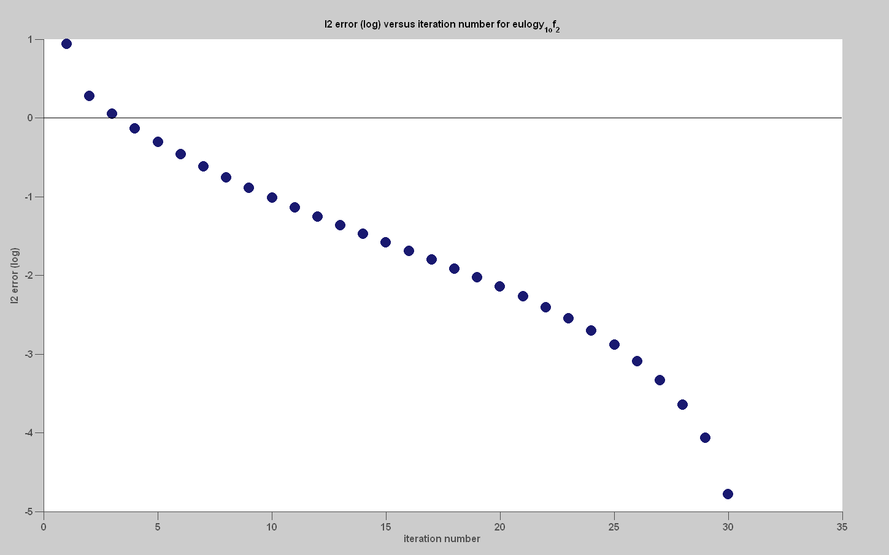
Figure 44 - log l2 error versus iteration for audio

Project Schedule

Proposed timeline
- October/November – code alternate projections (8 weeks)
- December – write up mid-year report (2 weeks)
- January – code local maxima search (1 week)
- February/March – test and debug entire system (8 weeks)
- April – run code against database (4 weeks)
- May – write up final report (2 weeks)

Actual timeline
- October/November – The DWT, IDWT, local extrema search, the projection and projection are coded and tested.
- December – Mid-year presentation is prepared.
- January – Mid-year report is prepared. Dr. Balan discovers a typo in Mallat’s and Zhong’s paper [1] and the projection bug is corrected.
- February-April – Tests against baseline signals do not yield satisfactory results. Two bugs in IDWT are discovered and corrected.
- May – Final report and presentation prepared.

Milestones

Proposed Milestones
- December 1, 2010 – alternate projections code passes unit test
- February 1, 2011 – local extrema search code passes unit test
- April 1, 2011 - codes passes system test

Deliverables
- MATLAB code – The submitted code will be commented, modular, and extendable. Scripts will be included to reproduce results of testing.
- Final report – The report will explain how the algorithm was implemented and the results of testing.

Bibliography
[1] | S. Mallat and S. Zhong, "Characterization of Signals from Multiscale Edges," IEEE Transactions on Pattern Analysis and Machine Intelligence, vol. 14, no. 7, pp. 710-732, Jul. 1992.
[2] | D. Youla and H. Webb, "Image restoration by the method of convex projections," IEEE Transaction on Medical Imaging, vol. Ml-l, pp. 81-101, Oct. 1982.

