HOMEWORK 2

Section 2.4 - 50,59,64,65
Extra Problem
50

  - P(M ∩ LS ∩ PR) = .05, directly from the table of probabilities

  - P(M ∩ Pr) = P(M,Pr,LS) + P(M,Pr,SS) = .05+.07 = .12

  - P(SS) = sum of 9 probabilities in SS table = .56, P(LS) = 1 - .56 = .44

  - P(M) = .08+.07+.12+.10+.05+.07 = .49
P(Pr) = .02+.07+.07+.02+.05+.02 = .25

  - P(M|SS ∩ Pl) =

  - P(SS|M ∩ Pl) =
P(LS|M Pl) = 1 - P(SS|M Pl) = 1 - .444 = .556

59

$\text{.}4×\text{.}3=\text{.}\text{12}=P(A_{1}∩B)=P(A_{1})⋅P(B|A)$$\text{.}\text{35}×\text{.}6=\text{.}\text{21}=P(A_{2}∩B)$
  - 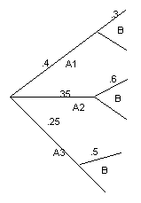$\text{.}\text{25}×\text{.}5=\text{.}\text{125}=P(A_{3}∩B)$ P(A₂ ∩ B) = .21

  - P(B) = P(A₁ ∩ B) + P(A₂ ∩ B) + P(A₃ ∩ B) = .455

  - P(A₁|B) = , P(A₂|B) = , P(A₃|B) = 1 – .264 – .462 = .274

64

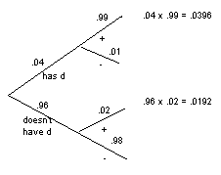
  - P(+) = .0588

  - P(has d | +) =

  - P(doesn’t have d | - ) =

65.

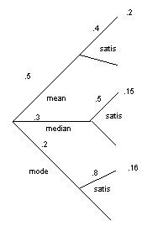

P(satis) = .51
P(mean | satis) =
P(median | satis) = .2941
P(mode | satis) = .3137
So Mean (and not Mode!) is the most likely author, while Median is least.

Extra Problem:
In a 7 card poker hand find the probability of 3 pairs and one more kind, e.g. JJQQKKA.

